  26/10/2015



Contents

PROJECT PLAN 2

1.1 Introduction 4

1.2 Milestones and Deliverables 5

1.3 Task List 6

1.4 Project Schedules 7

1.5 Risk Management 8

1.6 Technical Feasibility Issues 12

1.7 Economic Feasibility Issues 13

1.8 Team Members 16

Requirements Analysis 38

1. Problem Domain 39

2. Solution Domain 41

3. Logical System Model 42

4. Class Diagram 45

5. Appendix A 48

DESIGN DOCUMENT 49

1. Introduction 50

2. Logical Architectural Design 51

3. User Interaction Design 55

4. Database Design 75

5. Report Design 83

6. Appendix B 88

MINUTES 89

# PROJECT PLAN

Number of the team: 6

name of the team: Express core

Team Members

Team leader:Duran Moodley: 13016335

Matthew harmsworth

Steve Lunga: 13017895

Mishka ramburan: 14008535

Matthew hutchings

CALVIN REed: 13012647

# **1.1 Introduction**

**Needs that the Application needs to satisfy**

The Application that is being developed needs to solve the numerous errors that Cargo Fleet are experiencing with the current system and it needs to reduce the frequency of those errors. The application needs to generate a wide variety of reports. They are:

* Vehicle Status Reports
* A daily and weekly service report
* Service Requirement Job sheet
* Daily, weekly, monthly and yearly report on completed vehicle services
* Specific service report
* Daily/weekly planned trip report
* Daily/ weekly/monthly completed trip report
* Daily/weekly/monthly time sheet report detailing how many hours each person worked

The application also needs to capture information and make sure that information is available. Furthermore, the application needs to aid the company in handling the current business processes. Activities such as: add, delete, update and view report are features that the company require. Therefore, the system needs to aid them in doing these activities.

**Goals of the Project**

* To develop software application that can satisfy the needs of cargo fleet
* An application that solve their numerous errors
* An application that is user friendly and produces accurate information in a timely manner
* Help handle the business processes effectively and efficiently.
* Allow information to be available to employees in the company.

**Cost Constraints (Budget)**

The consulting rate for this project is R850 per hour and there will be additional costs for the database application. Cargo fleet is not an NGO and therefore will need to pay the necessary fees.

**Risks**

There are a wide variety of risks that could jeopardize the project. To name a few they are:

Exceeding the proposed budget: If incorrect estimations on the costs are made this will lead to extra costs being incurred. This will not make the client happy.

Load shedding: The programmers of this project won’t be able to do any coding during these periods. Therefore, is a chance that the project could get delayed.

Shared Drive being hacked: The internet is a hostile environment that has a large number of potential hackers waiting to access unauthorized data. This could result in data theft.

**Benefits for the Customer if project is successful**

Due to the large amount of errors that occur with the current system, Cargo Fleet needs to hire another full-time administrator and pay added over time to the employees to fix those errors. Therefore, the Cargo Fleet will be saving in terms of cost. Furthermore, the application will enable the company to budget accurately because the new system will enable the Cargo Fleet to keep track of all costs. Additionally, Cargo fleet will be able to view all the reports which will allow the business to keep track of their business processes effectively and efficiently. Another added incentive to this project is that the business will be saving valuable time. Currently, the errors that the current system produces takes between 20 minutes and on average the system makes about 3 errors per day. Cargo Fleet will also be able to monitor which vehicles needs service and what type of service is required for that vehicle. This will help improve the life span of those vehicles so that they do not break down during a trip. This will ultimately preserve the reputation of the company and keep their clients for a longer period of time. Lastly, once the system has been developed it will be leased to other transport companies. This will result in a further decline of expenses for Cargo-Fleet.

# **1.2 Milestones and Deliverables**

**Deliverables**

* Complete work breakdown structure
* Assemble a project Schedule
* Determine the risks of the project.
* Determine the technical feasibility of the project
* Calculate the economic feasibility

**Milestone**

* Analysis document

# **1.3 Task List**

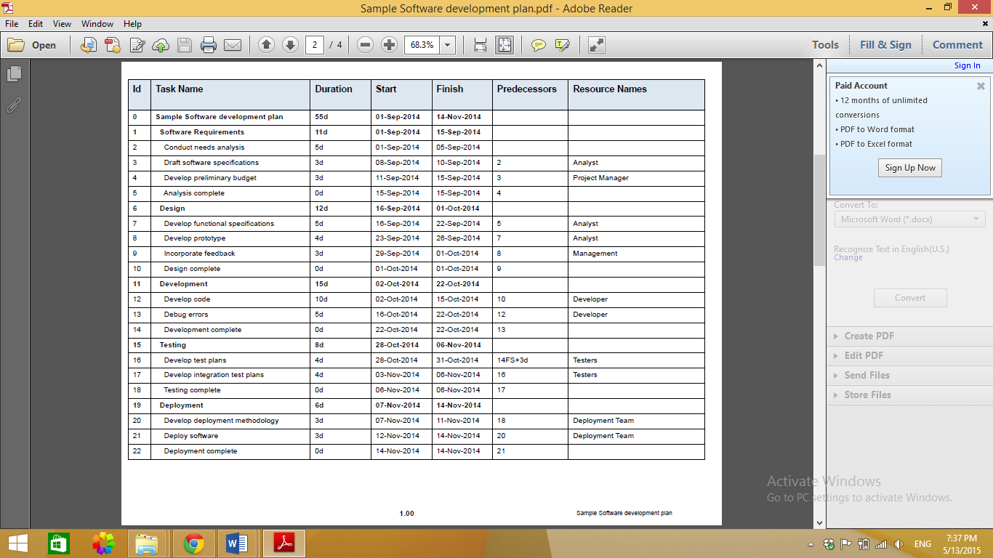

# **1.4 Project Schedules**

## 1.4.1 Gantt chart and Interpretation

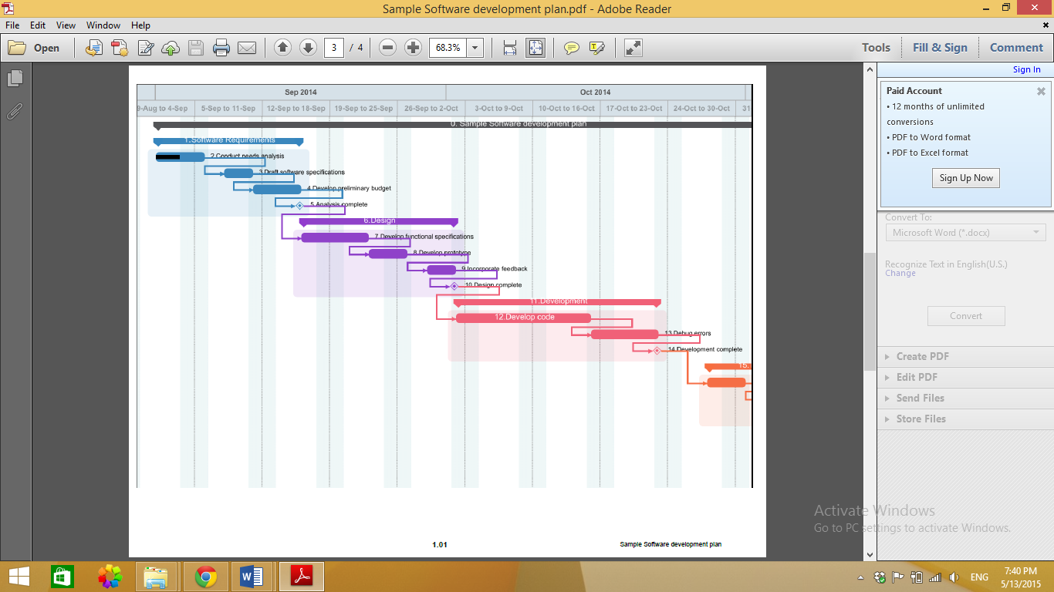

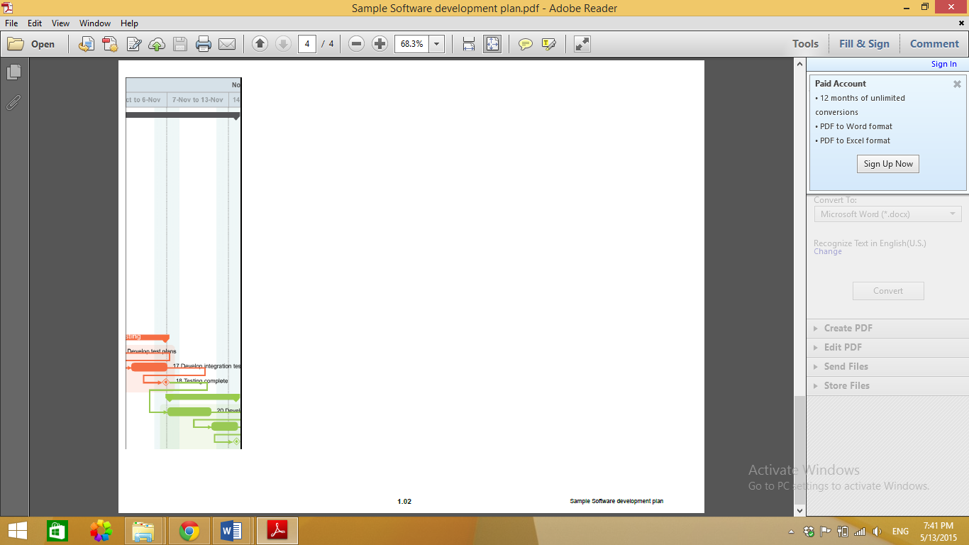

# **1.5 Risk Management**

|  |  |  |  |  |
| --- | --- | --- | --- | --- |
|  | Risk | Risk Category | Risk Defined | Response |
| 1. | Staff Leaving – | Staff | If any key personal / executive leaves the company | Accept  Make sure that another individual can fill in for the person leaving the group. Recruit a new employee. |
| 2. | Misunderstood requirements – | Communication | Requirements misunderstood due to a break in the communication channel on what is expected. The programmer may not understand the full requirements and what is expected if the design document is not clear | Mitigate  The receiver of each message needs to listen carefully and ask for help if they are not sure on an instruction or contact me if things are still not clear |
| 3. | Resource shortages – | Resources | There is not enough sufficient resources to satisfy the needs of the project. | Avoid  Extra funds will be put into the project in case there is a problem with scares resources |
| 4. | Employee illness – | Staff | Workers / employees may pick up an illness on the way. Which could delay the completion of the certain tasks. | Accept  Re-assign another group member to complete the task that is outstanding. |
| 5. | Power outages –. | External | A sudden rush of high voltages after a power outage can have the same effective that lighting has on electronics where extra power and this is where damaged is caused | Mitigate  Special power surge appliances will be used to prevent any damages to equipment. |
| 6. | Hardware malfunctions – | Hardware | Technology is very unpredictable and if hardware is not operational , proceedings cannot take place and the project will have put on hold causing delays which can affect the time management of our company ( Business-Online-Basics ) | Avoid  Back up hardware must be on standby in case any hardware crashes and external storage must be used to protect saved from being lost. |
| 7. | Compatibility issues – | Hardware | The software could possibly not function on all operating systems and cross platforms. Software and hardware might have to be up to date in order to run the program. | Avoid  Tests will be made on multiple operating platforms and devices to assure that software is operational on them. If not, changes and upgrades will need to be made in order to fix the problem. |
| 8. | Poor Productivity – | Staff Moral | As time passes by , the lack of energy and motivation to complete the lengthy tasks may slow down the process of completing the project and decrease the quality of the project | Avoid  Incentives will be rewarded to staff for a job well done and appropriate work place conditions are in place for staff to utilize and work at their full potential. |
| 9. | Complexity – | Software | The layout and interface could possibly be too complex for users to operate, especially with all the functions and features. | Avoid  The design of the program should take into account all users. Therefore, the software must be constructed to cater for non-computer literate people. Feedback from the stakeholders is necessary during development. |
|  |  |  |  |

**Risk Matrix**

|  |  |  |  |  |  |
| --- | --- | --- | --- | --- | --- |
| **Probability** | | | | | |
| **Risk Description** | **Very Low** | **Low** | **Medium** | **High** | **Very High** |
| Staff Leaving |  |  |  |  |  |
| Misunderstood Requirements |  |  |  |  |  |
| Resource shortages |  |  |  |  |  |
| Employee illness |  |  |  |  |  |
| Power outages |  |  |  |  |  |
| Hardware malfunctions |  |  |  |  |  |
| Compatibility issues |  |  |  |  |  |
| Poor Productivity |  |  |  |  |  |
| Complexity |  |  |  |  |  |

|  |  |  |  |  |  |
| --- | --- | --- | --- | --- | --- |
| **Impact** | | | | | |
| **Risk Description** | **Very Low** | **Low** | **Medium** | **High** | **Very High** |
| Staff Leaving |  |  |  |  |  |
| Misunderstood Requirements |  |  |  |  |  |
| Resource shortages |  |  |  |  |  |
| Employee illness |  |  |  |  |  |
| Power outages |  |  |  |  |  |
| Hardware malfunctions |  |  |  |  |  |
| Compatibility issues |  |  |  |  |  |
| Poor Productivity |  |  |  |  |  |
| Complexity |  |  |  |  |  |

|  |  |  |  |
| --- | --- | --- | --- |
| Risk | Probability (1-5) | Impact (1-5) | Risk Factor |
| Staff Leaving | 2 | 4 | 8 |
| Misunderstood Requirements | 3 | 4 | 12 |
| Resource shortages | 2 | 4 | 8 |
| Employee illness | 2 | 3 | 6 |
| Power outages | 4 | 4 | 16 |
| Hardware Malfunctions | 2 | 4 | 8 |
| Compatibility issues | 2 | 4 | 8 |
| Poor Productivity | 3 | 3 | 9 |
| Complexity | 2 | 4 | 8 |

# **1.6 Technical Feasibility Issues**

Hardware Resources

|  |  |  |
| --- | --- | --- |
| Resources Needed | Availability / Problem Solving | Reason for the Resource |
| Computers | Yes, our team each has a either a desktop or laptop. | Working off them is extremely vital as they are needed to create, test and fix the clients software. |
| Printers | Yes, most of us have a personal printer at home. | Printing out project plans, ideas, progress charts e.g. for the client. |
| Portable Drives | Yes, each member of the team has this. | e.g. USB’s / external HDD’s will be used for transferring data to other computers or taking around to show the client new work being done. This will only be used has a back-up plan incase our cloud services don’t work. |
| Smartphones | Yes, all team members have the use of a smartphone. | This will be to keep communication with the team and the client. |

Software Resources

|  |  |  |
| --- | --- | --- |
| Resources Needed | Availability / Problem Solving | Reason for the Resource |
| Microsoft Word 2013 | Yes, each member has this installed on their computers. | For creating the project plans, reports and cv’s. |
| Microsoft Project 2013 | No, not all members have this installed on their computers. The head programmer or project manager will organize this for the rest of the team. | This program is essential for the team to be able to create network diagrams, work breakdown structures and Gantt charts to plan our hours and when deadlines are as well as show the client how organized we are. |
| Microsoft PowerPoint 2013 | Yes, each member has this installed on their computers. | This will be for group meeting to show progress as well as for the client to see in a visual progress. |
| Microsoft Visual Studio 2013 | Yes, each member has this installed on their computers. | Designated team members will be using this to code and create the software for the client, other members shall give input and help out so its handy they also have the program installed on their computers. |
| Google Drive | Yes, each member has this installed on their computers. | Very import to have this as this is how we are sharing information and tasks with team members. |
| WhatsApp Group | Yes, each member has this installed on their smartphones. | An instant messenger to keep in contact in critical purposes. |
| Skype | Yes, each member has this installed on their smartphones and computers. | This is an alternate to WhatsApp but it allows us to have group discussions via voice. |

# **1.7 Economic Feasibility Issues**

Economic Feasibility – is to analysis the project costs and revenues in an effort to determine whether or not it is logical and possible to complete as well as to determine the positive economic benefits to the organization that the proposed project system will provide to find if the identification and quantification of all the benefits expected.

|  |  |  |  |  |
| --- | --- | --- | --- | --- |
| Task Identification | Team member(s) responsible | Time allocated per task per team member | Tariff per team member in Rand per hour | Cost per task(time*tariff) |
| Conduct needs analysis | Mishka  Duran  Lunga  Calvin  Harmsworth  Hutch | 120 Hours | R70 | R8400 |
| Draft software specifications | Lunga  Calvin  Harmsworth  Hutch | 72 Hours | R100 | R7200 |
| Develop preliminary budget | Mishka  Hutch | 72 Hours | R30 | R2160 |
| Analysis complete | Mishka  Duran  Lunga  Calvin  Harmsworth | 0 Hours | 0 | 0 |
| Develop functional specifications | Harmsworth  Hutch | 120 Hours | R90 | R10800 |
| Develop prototype | Mishka  Hutch | 96 Hours | R80 | R7680 |
| Incorporate feedback | Mishka  Duran  Lunga  Calvin  Harmsworth | 72 Hours | R30 | R2160 |
| Design complete | Mishka  Duran  Lunga  Calvin  Harmsworth | 0 Hours | R0 | R0 |
| Develop code | Calvin  Harmsworth  Mishka | 240 Hours | R200 | R48000 |
| Debug errors | Calvin  Duran  Hutch | 120 Hours | R100 | R12000 |
| Development complete | Mishka  Duran  Lunga  Calvin  Harmsworth  Hutch | 0 Hours | R0 | R0 |
| Develop test plans | Mishka  Duran  Lunga  Calvin  Harmsworth  Hutch | 96 Hours | R30 | R2880 |
| Develop integration test plans | Mishka  Duran  Lunga  Calvin  Harmsworth | 96 Hours | R50 | R4800 |
| Testing complete | Mishka  Duran  Lunga  Calvin  Harmsworth  Hutch | 0 Hours | R0 | R0 |
| Develop deployment methodology | Mishka  Duran  Lunga  Calvin  Harmsworth  Hutch | 72 Hours | R80 | R5760 |
| Deploy software | Mishka  Duran  Lunga  Calvin  Harmsworth  Hutch | 72 Hours | R150 | R10800 |
| Deployment complete | Mishka  Duran  Lunga  Calvin  Harmsworth  Hutch | 0 Hours | R0 | R0 |

# **1.8 Team Members**

**Team Leader/Programmer**

**Responsibilities**  Duran Moodley

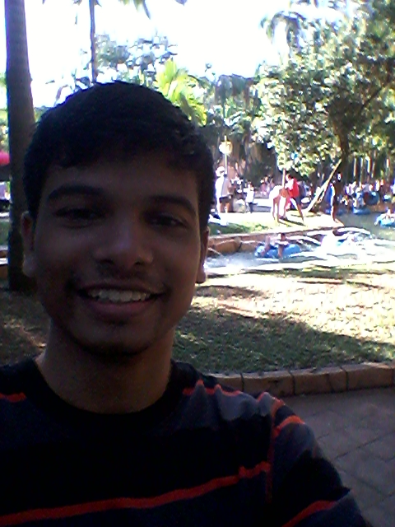

* Delegate Tasks amongst group members
* Guide group members to produce accurate work
* Monitoring the activities of all group members
* Does the programming
* Fixing mistakes (Debugging)

Steve Lunga

 **Database Developer**

**Responsibilities**

* Handles some of the documentation
* Designs the database
* Constructs the database design
* Assists with the coding

**System Designer** Matthew Harmsworth



**Responsibilities**

* Does the non-technical aspects of the project
* Designs the class diagrams
* Designs ERD diagrams
* Creates the databases
* Inputs sample data
* Participates in the programming

Mishka Ramburan

**Secretary**

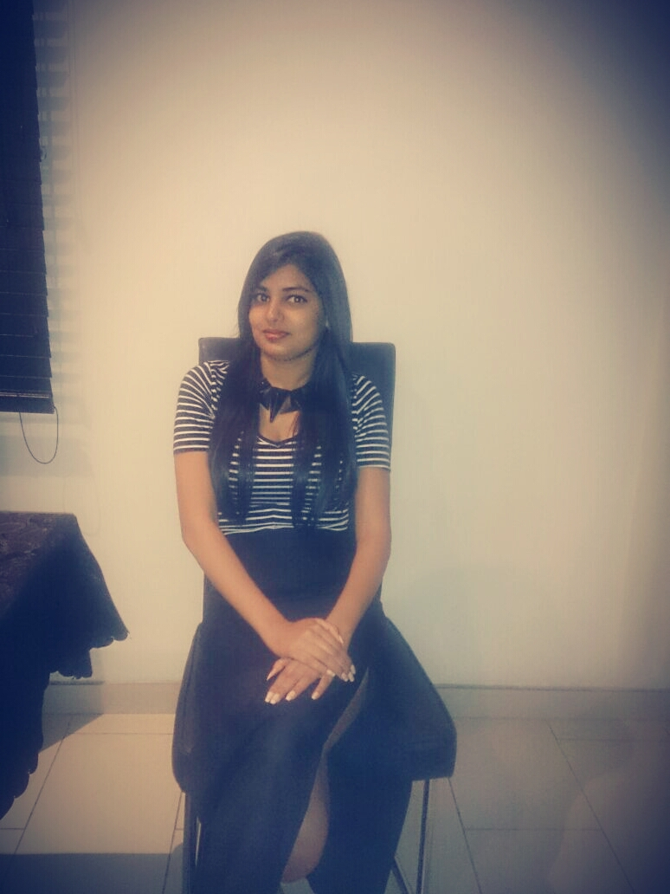**Responsibilities**

* Handles some of the documentation of the project
* Helps with the database creation
* Does system testing of the system
* Looks for any errors
* Designs some of the class diagrams

**Programmer**

**Responsibilities Calvin Reed**



* Handles some of the documentation of the project
* Helps with the database creation
* Does system testing of the system
* Debugger
* Designs some of the class diagrams
* Programs certain areas of the software

**Programmer/Database Designer Matt Hutchings**



**Responsibilities**

* Does some of the documentation
* Designs user interactions
* Programs certain areas of the software
* Designs and creates the databases

**CURRICULUM VITAE**

**Duran Moodley**

|  |  |  |  |
| --- | --- | --- | --- |
| **PERSONAL DETAILS** | | **CONTACT DETAILS** | |
| **ID Number** | **9504125163081** | **Cell phone Number** | **0713558911** |
| **Nationality** | **South African** | **Home Number** | **0313038517** |
| **Gender** | **Male** | **Email address** | **duranmoodley97@gmail.com** |
| **Languages** | **English** | **Postal Address** | **Unit 2 Flamboyant**  **215 Percy Osborn road**  **Morningside, Durban** |
| **License** | **Approved** | **Transport** | **Travel with a friend** |

**SUMMARY**

I see myself as being a hard working individual who will always give the best in any task that I encounter. I do feel that my communication skills have developed over the years which now enables me to speak to different people furthermore, I interact with all types of people on a regular basis. Lastly, I have been faced with many challenges throughout my schooling and varsity life but I have always fought through those challenges with determination and commitment.

**EDUCATION ACQUIRED AND SKILLS**

**Tertiary**

Institution:Varsity College (Independent Institute of Education)  
Qualification: Diploma in Software Development

Duration: 2014-2016

**Secondary**

Institution:Clifton College

Highest grade: Matriculation

Year Matric: 2013

Subjects: Maths core, Drama, IT, Accounting

**Skill set One:** I am an actor and dancer. I have recently participated in the Roshan Singh Mamma Mia Musical 2 production. I was the lead actor.

**Skill set Two:** I work very well with a computer as I am currently studying IT. I can create word documents, excel spreadsheets and I know my way around database application.

**ACHIEVEMENTS**

* Best senior performer for 2013 (drama)
* The Most hard working student 2013(award)
* School Prefect
* Full colours for Drama
* Half colours for Choir
* Lead Actor in a National Production (Mamma Mia Musical 2)

**WORK EXPERIENCE**

**Company Name: Varsity College (Durban North)**

Position Held: Registration Assistant

Period of Employment: December 2014 – February 2015

Key Duties: Made Student Cards

Entered Student Fingerprints into the biometric system

Helped Students with Unisa and UFS online registration

Registered Students to Varsity College

Interacted with parents and students as well as toured them around Varsity College

**VOLUNTARY WORK EXPERIENCE**

**Company Name: Roshan Singh Productions**

Position Held: Lead Actor and Dancer

Period of Employment: April 2014-December 2014

Key Duties Had interviews done by Dstv

Lead Actor in a Musical

Danced at big functions held at Sibiya, ICC, Phoneix fair and Durban City Hall

**REFERENCES**

**Name of Reference**: Mitchell Lupton

Name of Company: Varsity College

Job title: Registration Assistant

Contact Details: 031 573 2038

05/15/2015

To whom it may concern

**RE. MATT HUTCHINGS – EMPLOYMENT APPLICATION**

I am writing to you with regards to employment opportunities that may exist in your Software Development Department.

I am passionate about the Industry and my dream would be to work in this field and in particular for your company.

My goal would be to gain an entry level position in the field, over time I would like to expand my experience and skills to move higher up in the ranks.

I am hard working, enthusiastic, disciplined and a quick learner.

I have identified your business as one of the most progressive companies in this field and I believe the company culture, open plan / communication would complement my personality.

Thank you for considering my application and I look forward to hearing from you at your earliest convenience.

Kind regards

Matt Hutchings

073 8444 664

**MATT HUTCHINGS - CURRICULUM VITAE**

**PERSONAL INFORMATION**

Name & Surname:

Matthew Alexander Hutchings

Contact Information:

Cell – 0738444664

Email – [00.Matt.Hutch@gmail.com](mailto:00.Matt.Hutch@gmail.com)

ID number:

9311015055082

Address:

68 Anthony Rd, Number 1 Ishumi, Umgeni Park / Durban North

Transport:

Yes

Languages:

English

Availability to start employment:

Immediate

**Profile**

* Passionate about gaming, computers, technology and design
* Strong communication skills
* Enthusiastic
* Outgoing
* Positive
* Hard working

**COMPUTER LITERACY**

* MS Word Advanced Literacy
* MS PowerPoint Advanced Literacy
* MS Excel Advanced Literacy
* Ms Project Advanced Literacy
* Visual Studio Advanced Literacy
* Internet Advanced Literacy
* Installing & Configuring Windows Intermediate Literacy

**EDUCATIONAL HISTORY**

**SCHOOL ATTENDED: Embury College / Curro Embury College**

Year Matriculated: 2012

Subjects Passed:

* BUSINESS STUDIES
* ENGLISH HOME LANGUAGE
* HISTORY
* LIFE ORIENTATION
* MATHEMATICAL LITERACY
* VISUAL ARTS

**Achievements:**

* The Edwina Grossi Award for star pupil of the year

**Extra Mural Activities Participated In:**

Matric Year:

* 1st Team Rugby
* 1st Team Squad Swimming
* Community Service Helper

Grade 11 Year:

* 1st Team Soccer
* 1st Team Rugby
* 1st Team Squad Swimming

**COLLEGE ATTENDING: Varsity College**

Graduation Year: 2016

Course: Information Technology in Software Development

**Hobbies**

* Xbox
* Soccer
* Swimming
* Learning about computers
* Assembling computer components
* Learning about new computer software

**EMPLOYMENT HISTORY / PART TIME EMPLOYMENT HISTORY:**

**Company Name:** Hops

**Duration of Employment:** December 2012 - current

**Position Held**: Barman

**Duties:**

* Served food & beverages
* Running of various errands
* Stock count
* Cleaning of the Bar
* Worked at important functions
* Cash up / Bar’s money counting
* Training of new Bar Staff

**Reason for leaving:** Hours were long and needed to focus on College work

**Company Name:** Cocktails & Caviar

**Duration of Employment:** November & December 2011

**Position Held:** Waitron

**Duties:**

* Served food & beverages
* Assisting at major functions including the Cop17 Convention

**Reason for leaving:** Work experience

**Company Name:** Green with Envy

**Duration of Employment:** November – December 2010

**Position Held:** Waitron

**Duties:**

* Served food & beverages

**Reason for leaving:** Work experience as part of a school project

**REFERENCES:**

1. Company Name: Hops

Name of Referee: Brad

Position: Manager

Contact information: 0741818546

1. Company Name Cocktails & Caviar

Name of Referee: Mike

Position: Manager

Contact information: 0844680929 / [Mike@cocktailcc.co.za](mailto:Mike@cocktailcc.co.za)

Lunga Magadla

**Personal Information**

**Full name:** Lunga Bongumusa

**Surname:** Magadla

**Date of Birth:** 31 October 1995

**Identity Number:** 951031 5242 080

**Nationality:** South African

**Gender:** Male

**Home Language:** English, Zulu and Xhosa

**Personal Profile**

* Hard working
* Outgoing
* Positive
* Work well with others

**Computer Literacy**

* MS Word – Advanced
* MS PowerPoint – Advanced
* MS Excel – Advanced
* MS Access – Advanced
* Internet - Advanced

**Educational Background**

**Tertiary Education**

**Institution:** Independent Institution Education: Varsity College, Durban north

**Period:** 2014 – 2016

**Year Completed:** First Year

**Current Year of study:** Second Year

**Diploma:** Information Technology in Software Development

**Secondary Education**

**Institution:** Matriculated – Queen’s College Boys High School, Queenstown

**Period of study:** 2009 - 2013

**Subjects:** English

Xhosa

Life Orientation

Life Science

Business Studies

Computer Application Technology

**Hobbies**

* Playing and watching Rugby and Soccer.
* Enjoy gaming (Xbox, playstation and computers).
* Making and listening to music
* Learning and understanding more about computers
* Going out and having fun meeting new people

CV

Personal Information

Name: Matthew

Surname : Harmsworth

ID Number : 9411035076082

Address : 252 Hyacinth Flats , 7 Avondale Road , Morningside

Languages : English

Transport: Yes

Availability to start employment : Immediate

Sex : Male

Race : White

Shirt Size : Large

Pant Size : 36

About me :

I’m the type of person that enjoys participating in activities , especially if its outdoors ,I’ve always been a sporting person . Reason being is that I’m very competitive and I love interacting with people and at the same time making new friends . I’m all about positive energy and I always try bringing what I can to the table . I love living a healthy lifestyle day in and out by keeping fit and eating healthy while maintaining a positive mindset . I feel that everything you do needs some form of balancing meaning that you shouldn’t focus on one thing ,but rather multiple sectors to keep your mind busy and your body active.

Qualities :

* Enthusiastic
* Outgoing
* Friendly
* Positive
* Punctual

Computer Literacy

* MS Word
* MS PowerPoint
* MS Excel
* MS Access
* Installing & Configuring Windows
* Internet

Education

High School : Glenwood

Year Matriculated : 2013

Matric Pass : Bachelor’s Degree

Subjects :

* Mathematical Literacy
* English Home Language
* Life Orientation
* Business Studies
* Computer Application Technology
* Tourism
* Afrikaans 1st language

Academic Achievements

* 1st in class Grade 8

Sports Achievement

* Most improved Rugby player Glenwood 2012
* 1st team Rugby for Glenwood 2013
* Sharks u21 extended squad
* KZN Ice Hockey 2009
* KZN Ice Hockey 2010
* KZN Ice Hockey 2011
* USSA Rugby Tournament 2014 Best forward player of the week
* Marching band half colours

Collage attending : Varsity Collage Durban North

Starting year : 2014

Graduation Year : 2016

Hobbies

* Rugby
* PlayStation
* Hiking
* Site seeing
* Going to the gym
* Jogging
* Working with computers / Using and discovering new software

Work Experience:

* Promotional work for three years
* Vet assistant ( School work experience)

Company of employment : Leading Edge Durban

Contact Details

Cell : 0785108104

Home : 031 309 2998

Email : [harmsworthmatthew@gmail.com](mailto:harmsworthmatthew@gmail.com)

Medical Aid : Momentum

C u r r i c u l u m

V i t a e

of

Mishka

Ramburan

35 Westmount Drive 26 July 2015

Broadlands

Mount Edgecombe

4156

To Whom it may concern

Dear Sir/Madam

***Re : Application for a vacancy***

A copy of my Curriculum Vitae detailing my experience and qualification is attached for your consideration. Briefly, I completed my matric through Solvista Secondary School in 2013 and obtain a Bachelor pass.I thereafter registered through Varsity Colleague in 2014 for a course in Information Technology (Software development). I completed my first year of studies and am currently in my second year.

I may be contacted on cell 0717306941 or alternatively, 0834441002.

Yours faithfully

Mishka Ramburan

PERSONAL DETAILS

|  |  |
| --- | --- |
| Full Names | Mishka Ramburan |

|  |  |
| --- | --- |
| ID Number | 9603150126086 |

|  |  |
| --- | --- |
| Date of Birth | 15 March 1996 |

|  |  |
| --- | --- |
| Race | Indian |

|  |  |
| --- | --- |
| Gender | Female |

|  |  |
| --- | --- |
| Disability Status | None |

|  |  |
| --- | --- |
| State of Health | Excellent |

|  |  |
| --- | --- |
| Home Language | English |

|  |  |
| --- | --- |
| Nationality | South African |

|  |  |
| --- | --- |
| Postal Address | Cluster Box 24321, Mount Edgecombe, Broadlands, 4156 |

|  |  |  |
| --- | --- | --- |
| Telephone No. | Home | Cell |
| (031) 5027457 | 0717306941 |

|  |  |
| --- | --- |
| Marital Status | Single |

|  |  |
| --- | --- |
| Drivers Licence | In process |

EDUCATIONAL QUALIFICATION

|  |  |  |
| --- | --- | --- |
| INSTITUTION | QUALIFICATION | SUBJECTS/MODULES |
| Solvista Secondary School | Grade 12 Senior Certificate | English  Afrikaans  Mathemathics  Life Sciences  Geography  Life Orientation  Business Studies |
| Varsity Colleague | National Diploma in Information Technology | Information Systems  Development Software  Systems Software  Technical Programming |

COMPUTER LITERACY

|  |  |
| --- | --- |
| INSTITUTION | PACKAGE |
| School | Introduction to MS Windows |
| Varsity Colleague | Complete Microsoft Office and programming |

SPECIAL ACHIEVEMENTS

|  |  |
| --- | --- |
| ACHIEVEMENTS | YEAR OBTAINED |
| Elected class representative | 2010, 2011 |
| Elected student leader(Prefect) in Matric | 2013 |

REFERENCES

|  |  |  |
| --- | --- | --- |
| NAME OF REFEREE | DESIGNATION | CONTACT DETAILS |
|  |  |  |

Curriculum Vitae of

**Calvin Reed**

**PROFESSIONAL PROFILE**

I am a hardworking, dedicated student. I have completed my first year in Software development; this has increased my knowledge in developing and improving my skills as a programmer. I have good people skills and am a good team player. I am able to follow proper procedure and protocol as well as being neat and organized when I work.

**PERSONAL DETAILS**

Surname: Reed

First Names: Calvin

Identity Number: 950609 5041 08 0

Nationality: South African

Gender: Male

Residential Area: Morningside

Home Language: English

Other Languages: Afrikaans

Email Address: calvinreed92@gmail.com

Cell Number: 082 804 0386

Drivers License: Code B

**SECONDARY EDUCATION**

Secondary School: Felixton College

Qualification: National Senior Certificate

Subjects Passed: English, Afrikaans, Life Sciences, History, Accounting,

Mathematics Core, Life Orientation

Year Obtained: 2013

**TERTIARY EDUCATION**

Institution: Varsity College

Course: IIE Diploma in Software Development

Current Level of Studies: 2nd Year

**COMPUTER SKILLS**

- Microsoft Office

- Java Programming (Net Beans IDE)

- C# Programming (Visual Studio)

**LEADERSHIP ROLES**

2013: Vice-Captain of 1st Team Hockey

2013: Active member of Environmental Committee

**ACHIEVEMENTS**

2011 - 2013: 1st Team Hockey

2014: 4 Distinctions in First year of studies

**EXTRAMURAL ACTIVITIES**

- Gym

- Hockey

**COURSES COMPLETED**

2011: Level 2 First Aid

**PART-TIME WORK EXPERIENCE**

Company Name: Debt-In

Period Employed: 08-09-2014– 27-11-2014

Job Title: Network Admin Assistant

Reason for leaving: Temporary Assignment

Main Job Functions: Network PC’s

Fix Headsets

Back Up data

Troubleshooting internet and network related issues

**REFERENCES**

Referee Name: Mr. Neil Read

Designation: Charted Accountant

Company Name: Neil Read and Co.

Tel No: 039-682 2566(Work) or 083-626 4762(Cell Phone)

Referee Name: Mr. Grant Richardson

Designation: Maintenance and construction Specialist

Company Name: Chevron South Africa

Tel No: 083 – 266 8878

Referee Name: Mr. Mark Essey

Designation: Director

Company Name: Debt-In

Tel No: 082 – 376 2782

# Requirements Analysis

1. **Problem Domain**

Cargo fleet has been experiencing various issues with their current system. The issues that the company is experiencing are the following:

* The reports that are being generated are not being updated correctly.
* Each report does not provide accurate information eg. The trip destination are incorrect.
* The mechanics’ often end up servicing the wrong vehicle because the reports are too clustered.
* The employees are often frustrated when using the program because it is too slow
* The interfaces that the employees are exposed to are often too distracting and do not make logical sense. This create confusion.
* The system is not user friendly. New users find it difficult to learn how the system works quickly.
* The system crashes for unknown reasons.

They have come to us “Express Core” for assistance in solving the above problems and to aid them in handling their business processes. Additionally, Cargo fleet requires a system that allows the company to generate various reports such as:

1. Vehicle Status Reports
2. A daily and weekly service report
3. Service Requirement Job sheet
4. Daily, weekly, monthly and yearly report on completed vehicle services
5. Specific service report
6. Daily/weekly planned trip report
7. Daily/ weekly/monthly completed trip report
8. Daily/weekly/monthly time sheet report detailing how many hours each person worked.

These reports need to be updated regularly and all information needs to be available to the users at all times. The application is also responsible for capturing information which includes information related to:

* Vehicles
* Employees
* Trips
* Vehicle Services
* Mechanics
* Drivers
* Mechanic Services

In order to gain access into the system. Employees need to enter in their login credentials consisting of a username and password. Depending on their title in the business, they will be given a certain amount of access to the system. An example of this is, if a driver enters his login details. He’ll be allowed to view the trip reports only. A vehicle administrator will only be allowed to do operations involving Vehicles. The office manager of Cargo Fleet will have access to the entire system.

**Projects Aim**

The project needs to be simple, user friendly and must work efficiently in order to meet the requirements and specifications of Cargo Fleet. The application should be able to populate and connect to the database effectively and making sure all data are stored accurately. In addition, if existing information needs to be changed. The system needs to be able update that record. Furthermore, if existing information is no more needed the user should able to delete that record. This operation should only be applied to Vehicles. Employees cannot be deleted, however, they can be disabled. This means that the employee record will still be available but that employee will not be allowed access into the system.

**Cost constraints**

Cargo fleet is not a NGO and therefore any fees or funds that will be needed during this project will be paid.

**Risks**

During the course of this project there may be various risks which need to be taken into consideration. These risks are:

1. Exceeding the proposed budget: If incorrect estimations on the costs are made this will lead to extra costs being incurred. This will not make the client happy. We will therefore have to work around the budget or make use of our own budget.
2. Load shedding:The programmers of this project won’t be able to do any coding during these periods. There is a chance that the project could get delayed and this could also impact our working hours. We will need to finish this project by a certain time period which can lead us to working overtime.
3. Shared Drive being hacked: The internet is a hostile environment that has a large number of potential hackers waiting to access unauthorized data. This could result in data theft.

**Benefits for the Customer if project is successful**

Due to the large amount of errors that occur with the current system, Cargo Fleet needs to hire another full-time administrator and pay added over time to the employees to fix those errors. Therefore, the Cargo Fleet will be saving in terms of cost. Furthermore, the application will enable the company to budget accurately because the new system will enable the Cargo Fleet to keep track of all costs. Additionally, Cargo fleet will be able to view all the reports which will allow the business to keep track of their business processes effectively and efficiently. Another added incentive to this project is that the business will be saving valuable time. Currently, the errors that the current system produces takes between 20 minutes and on average the system makes about 3 errors per day. Cargo Fleet will also be able to monitor which vehicles needs service and what type of service is required for that vehicle. This will help improve the life span of those vehicles so that they do not break down during a trip.

1. **Solution Domain**

|  |  |  |
| --- | --- | --- |
| 2.1 Participant(Active Actors) | 2.2 Functions | 2.3 Participant(Passive Actors) |
| Mechanic | Fix’s the mechanics and tangible assets of the vehicles. | Service Manager |
| Driver | Reports in to the kilometres travelled as well as the time it took to get from one destination to the other and delivers the cargo to the client. | Vehicle Information Administrator  Trip Manager |
| Officer Manager | Has access to the entire system. He makes sure that everyone is up to date with system. He notifies every one of any major changes. If anyone is experiencing problems with the system, he helps fix those issues |  |
| Trip Manager | This employee selects the routes for the cargo to travel on to make sure the destinations are reached on time and to avoid any mishaps. Traffic patterns, toll roads, truck specific routes and restrictions are also stated in the planning process. He updates, adds and can view reports about all trips completed and planned. | Driver |
| Service Manager | Takes note of all vehicles in the business that needs servicing to be done. He updates this information on the system and notifies the mechanics of the necessary work that needs to be completed. He can view reports that are related to services e.g. Service Appointment List | Mechanic |
| Timesheet Manager | Keeps track of the amount of work/hours done by both the Mechanics and the drivers in the business. This information is updated in the system. A report is also generated based on the hours done by a specific employee. |  |

1. **Logical System Model**

|  |  |  |  |
| --- | --- | --- | --- |
| GUI | | 3.3)System Process(Method) | 3.4) Entity Relationships(Tables) |
| 3.1)Input Specification | 3.2)Output Specifications |
| Enter Login Details | Error Message/ Successful Login Message | Check for the correct Login in the database | Employee Table  Mechanic Table  Driver Table |
| User to select Option from the Menu | Open the requested form e.g. View Reports | Checks which option is selected. Open appropriate form | No tables affected |
| Enter new Employee | Confirmation message | The new employee is inserted into the database table | Employee Table  Driver Table  Mechanic |
| Enter a new Vehicle | Confirmation message | Collects the vehicle information and sends to a database | Vehicle Table |
| Enter a new Trip | Confirmation Message | Collects the Trip information and sends to a database | Trip Table |
| Enter a new Vehicle Service | Confirmation Message | Collects the new Services for a vehicle sends to a database | Vehicle Service Table |
| Delete a vehicle | Confirmation Message | Captures the vehicle number. Searches in the database for that vehicle and deletes it | Vehicle Table  Trip Table  Vehicle Service Table |
| Update Vehicle | Confirmation Message | Searches for the vehicle being updated. Updates the relevant information | Vehicle Table |
| View Vehicle Report | Opens the report viewer | Collects information of all the vehicles in the database | Vehicle Table |
| Update Trips | Confirmation Message | Collects the trip Id number being updated. The id number is searched for in the database. The information is updated | Trip Table |
| Update Employees | Confirmation Message | Collects the Employee Id number being updated. The id number is searched for in the database. The information is updated. | Employee Table  Driver Table  Mechanic Table |
| Update Vehicle Service | Confirmation Message | Collects the Service Id number being updated and the Vehicle Number. The id numbers are searched for in the database. The information is updated. | Vehicle Services Table |
| Disable Employee | Confirmation Message | The Employee id number is captured. Search for in the database. This employee is then disabled | Employee Table |
| Timesheet Report | Opens the Report Viewer | Searches in the database for the employee id Number. Displays a report. Daily/weekly/Monthly Report | Mechanic Table  Driver Table |
| View Service Report | Opens the Report Viewer | Searches in the database for services done or services that are planned on a particular day/week/month or year. A search can also be made for a completed vehicle service or even a specific service done on a vehicle. | Service Table  Vehicle Service Table |
| View Trip Report | Opens the Report Viewer | Searches in the database for trips completed or those that are planned on a particular day/week/month. | Trips Table |
| Password Recovery | Confirmation Message | Searches in the database for the employee id number. Once found and email I sent to the specified email address containing the employees password | Employee Table  Driver Table  Mechanic Table |
| About | Information on Cargo Fleet | Displays pre-defined information about cargo fleet | No table affected |

1. **Class Diagram**







1. **Appendix A**

*The forms class diagrams that are specified in this document are similar to other forms in the program which are not specified. An add employee form class diagram has been specified. This class diagram looks similar to the add vehicle, service, and trip information which are not specified in this document. Therefore, the add employee form class diagram is used has a sample to represent those forms. The same applies to the update vehicle form which is used has a sample to represent the update functions for an employee, service and trip. The delete vehicle form, and daily weekly monthly yearly completed trip report are also samples used to represent the respective forms that have the same operations.*

# DESIGN DOCUMENT

1. **Introduction**

The program that we are developing consists of a number of components. It will first contain a login screen. If the user enters in their login credentials correctly, they will be allowed access into the system. Every employee has different levels of access into the system. A driver can only view trip reports but the officer manager has complete access to the entire system. After the login screen, the user will be shown a menu. This menu will contain an option for:

* Employees
* Vehicles
* Trips
* Services
* About

The first 2 options on the menu list will allow the user to add, delete, update and view information. However, trips and services do have a delete function.

Lastly, if a user has forgotten their password. They will receive an email with their forgotten password by simply entering in their ID number and their email address.

1. **Logical Architectural Design**
   1. High Level design



* 1. Low Level design



1. **User Interaction Design**

3.1Input Interactions

3.2 Requests Interactions

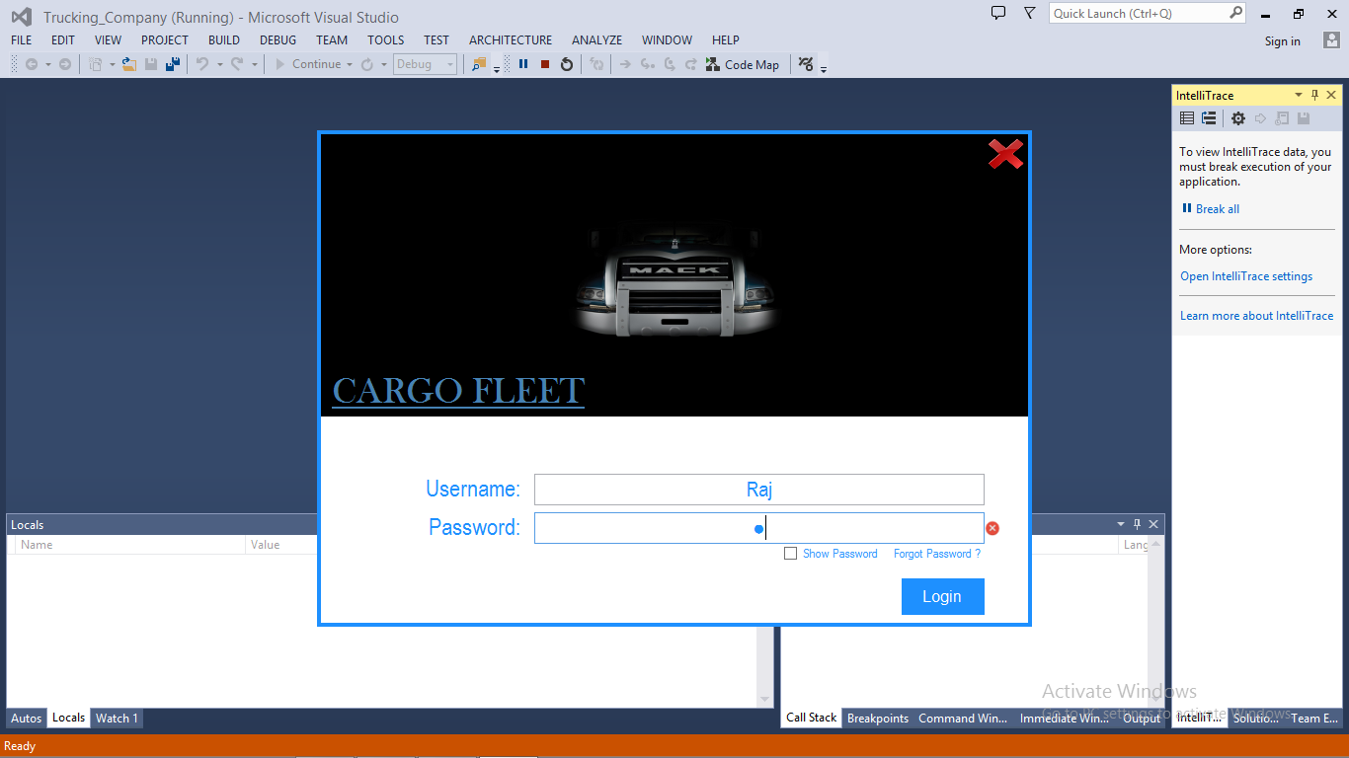

**Login Form:**

* A Username + Password Text box -> This is where the user will enter in his/her details but only if they have already got an account set up.
* Exit Button -> if the user wishes to close and exit the application, clicking this button will do so.
* Error Crosses -> if no details are entered or the wrong details are entered and he/she clicks the login button the form will show crosses next to the text boxes to show the user that something is incorrect.

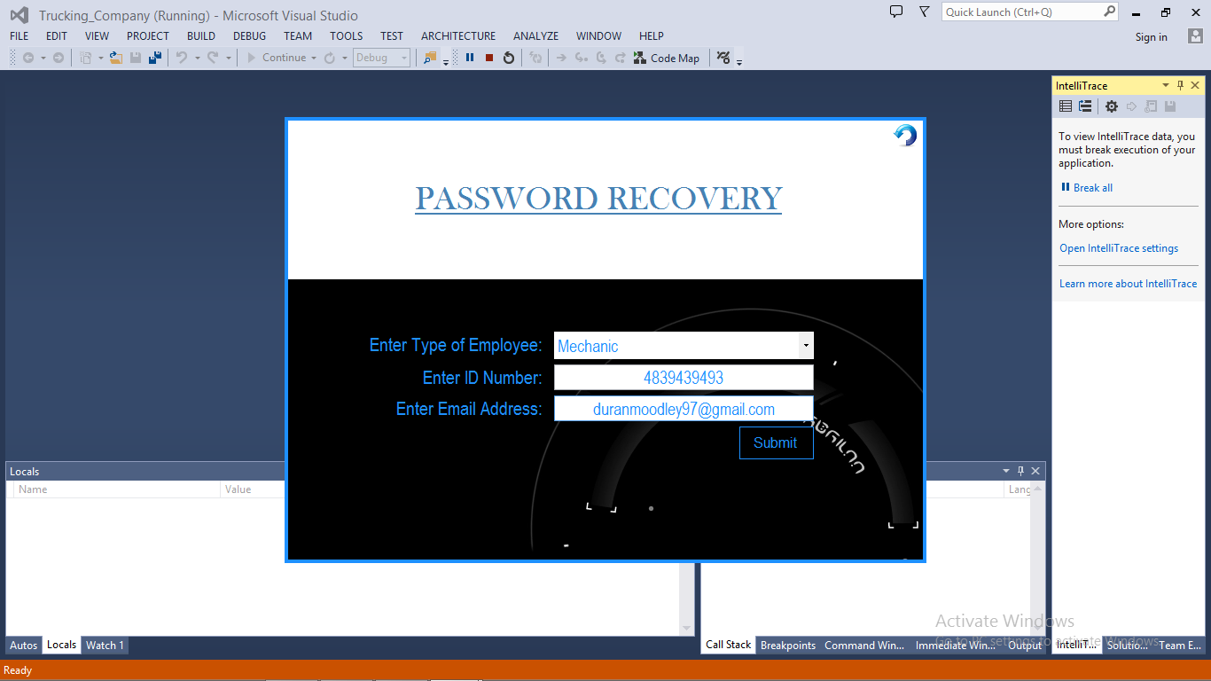**Password Recovery Form**

Clicking on “forgot password” label on the menu form will display this form.

The user needs to enter in their employee type, id number and email address. If found in the database, an email will be sent containing their password.

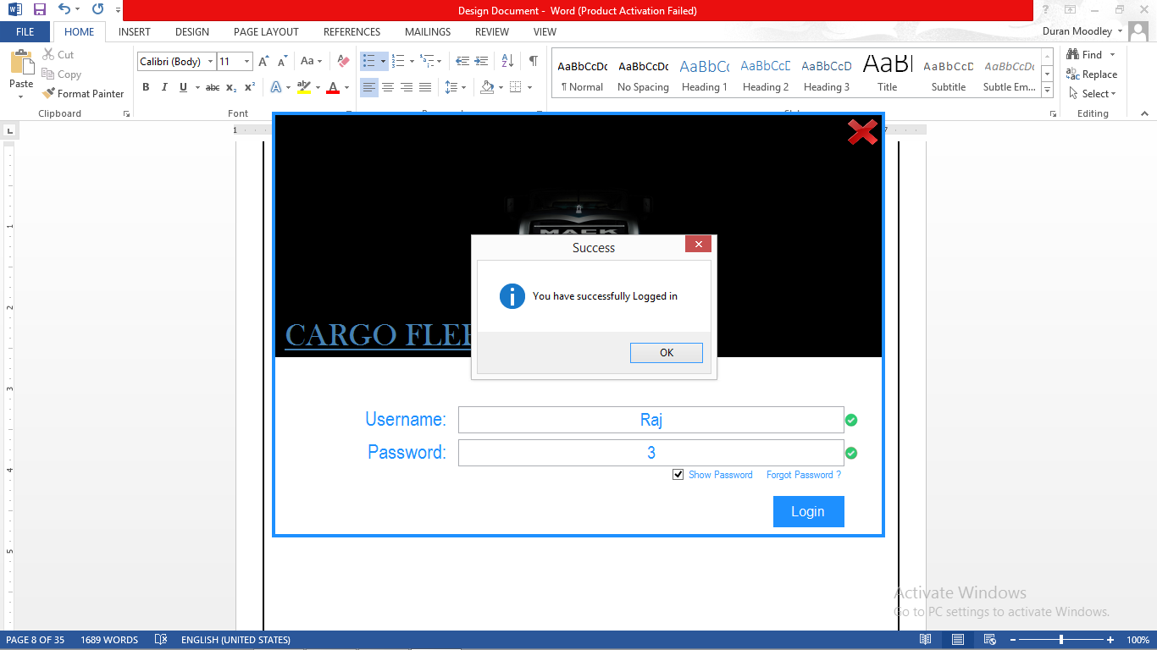

* The show password check box will allow the user to unmask their password.
* Clicking on Login will allow the user access into the system. A confirmation box will appear to confirm this. This confirmation box is seen throughout the program.
* If the credentials are incorrect. An error message will appear.

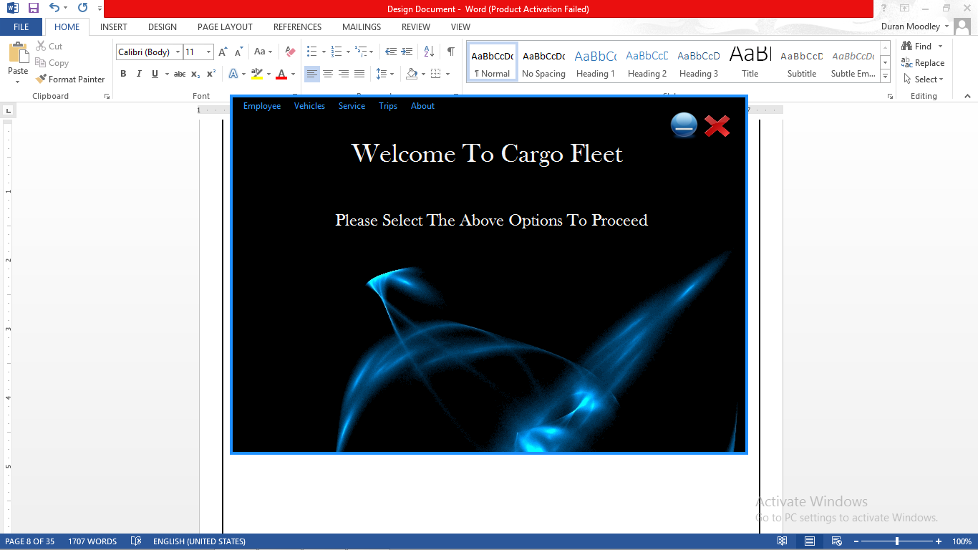

**Menu Form**

* This provides the user with a list of menu options
* The Red “X” will close the program.
* The Minimize button will minimize the program.

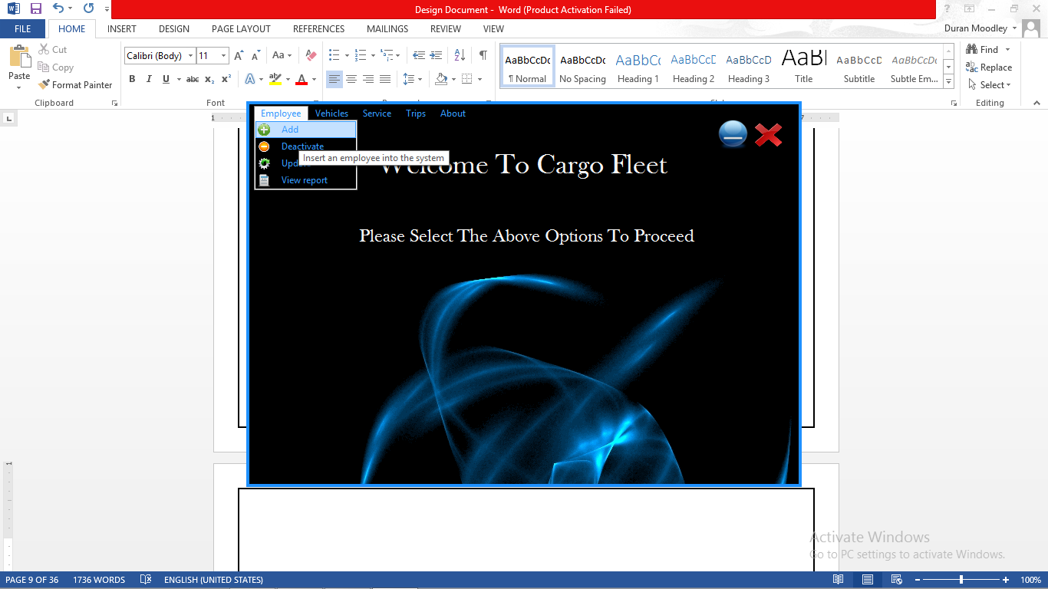

* Each menu option makes use of a tool tip.
* For an Employee those are the options that are available

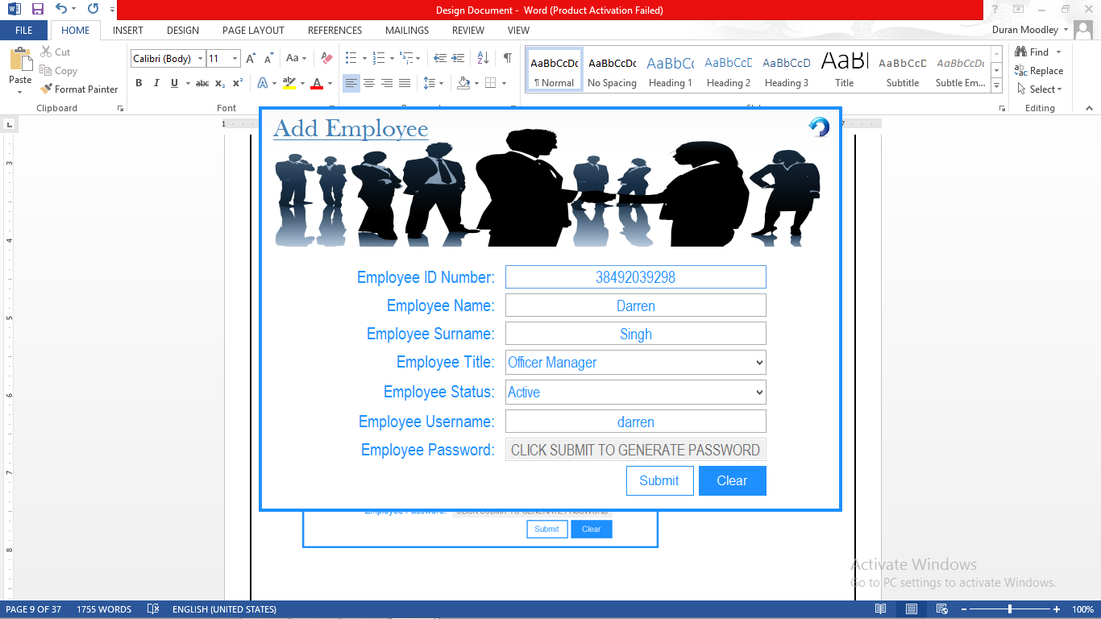

**Add Employee Form**

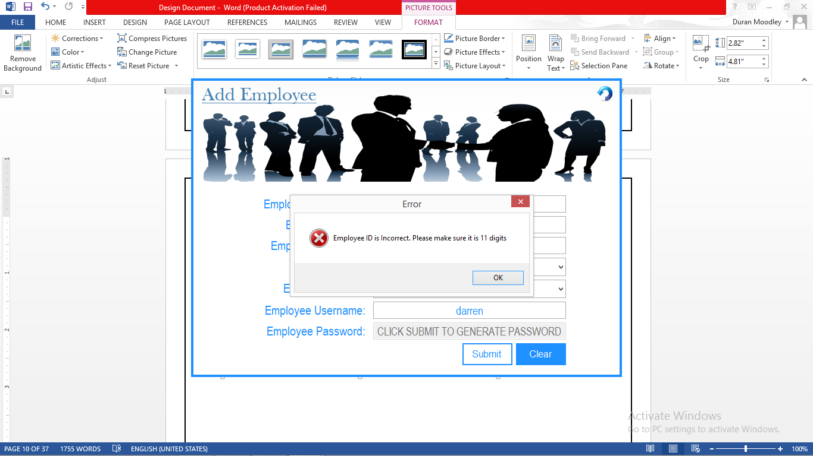

* If data is incorrectly entered an error message will appear. This is constant throughout the program.

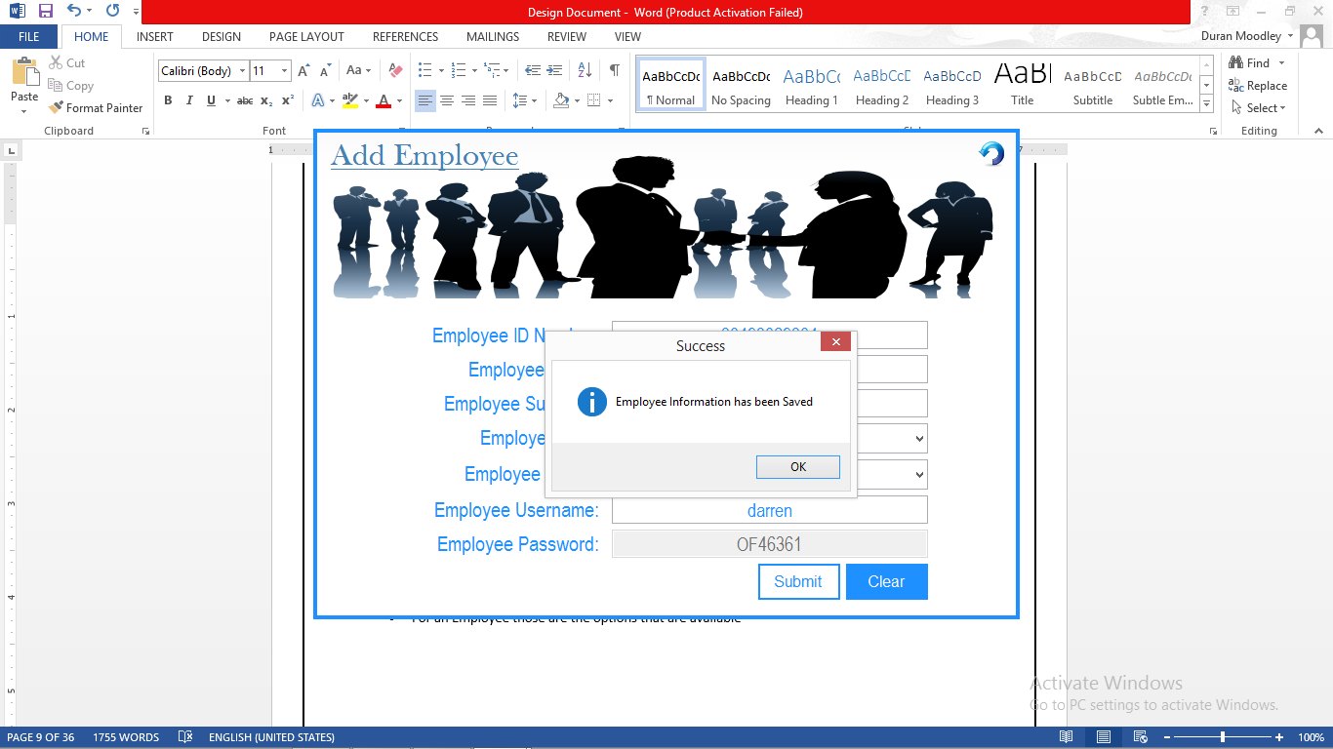

* Once the Submit button is clicked, a unique password will be generated. Consisting of the first 2 characters of the employee’s title, followed by a 5 digit random number.

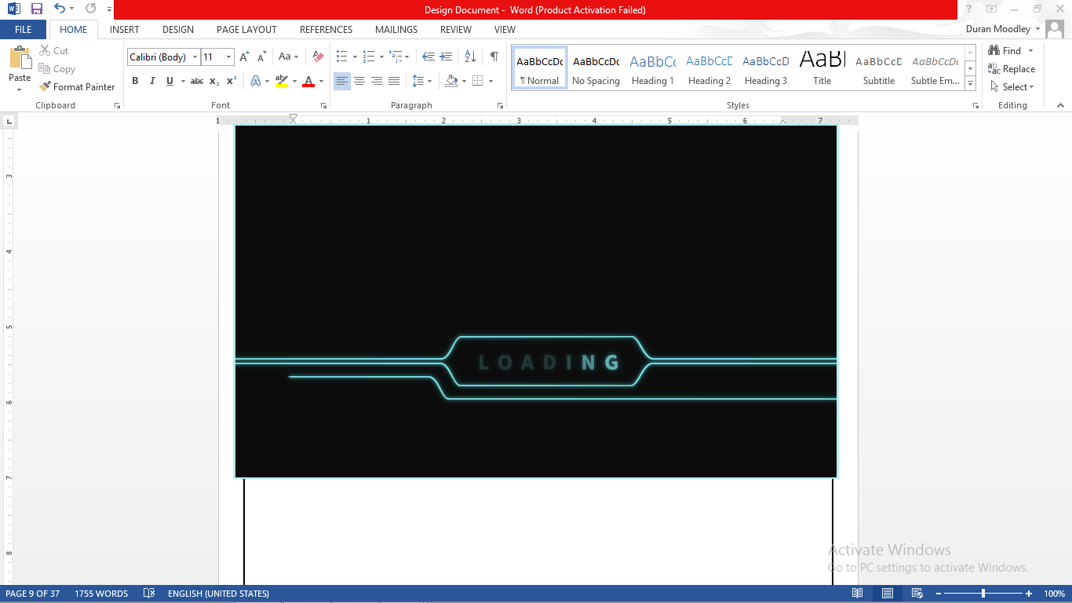

* This is a loading form which sends the data to the Database

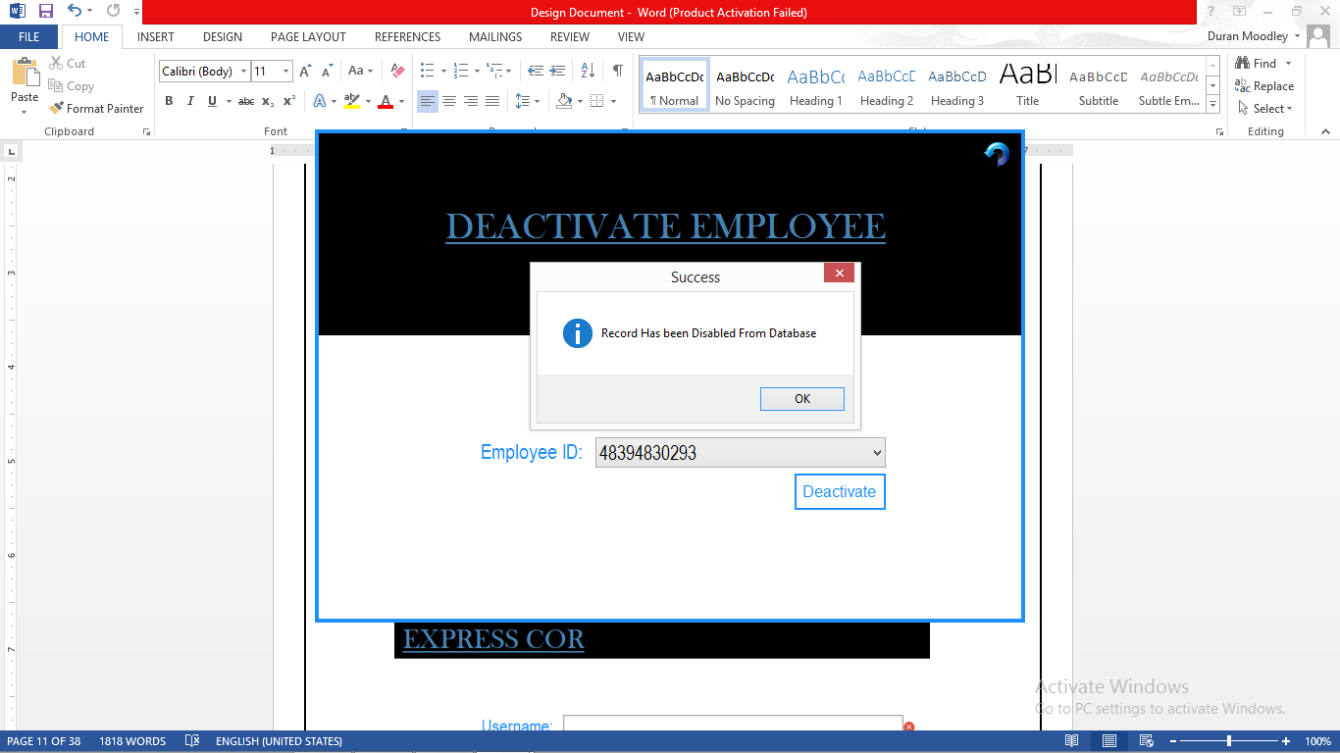

**Deactivate Employee Form**

* This form Disables/Deactivates and employee in the database
* The user needs to select an Id number from the drop list in the combo box
* The Deactivate button disables that Employee. This employee will not be allowed entry into this system.

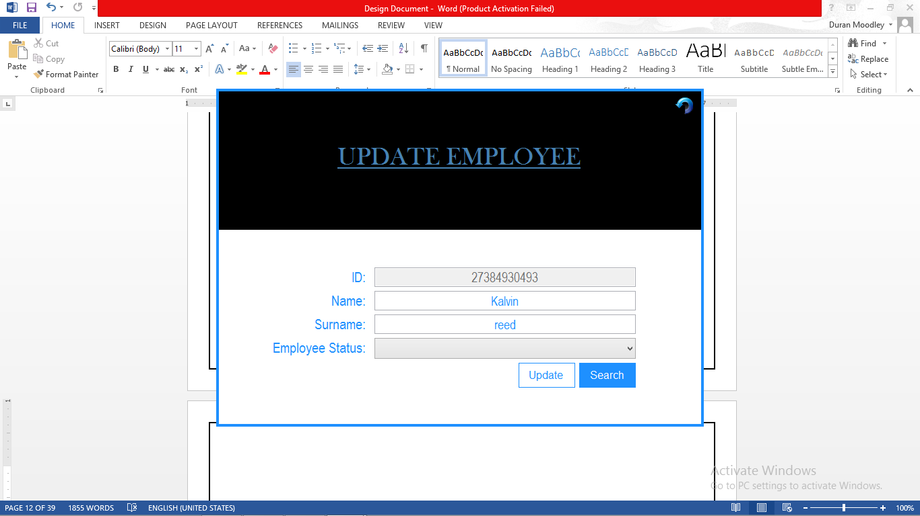

**Update Employee Form**

* The user needs to enter in the Id number of the employee to update
* Clicking on Search will display that user’s information.

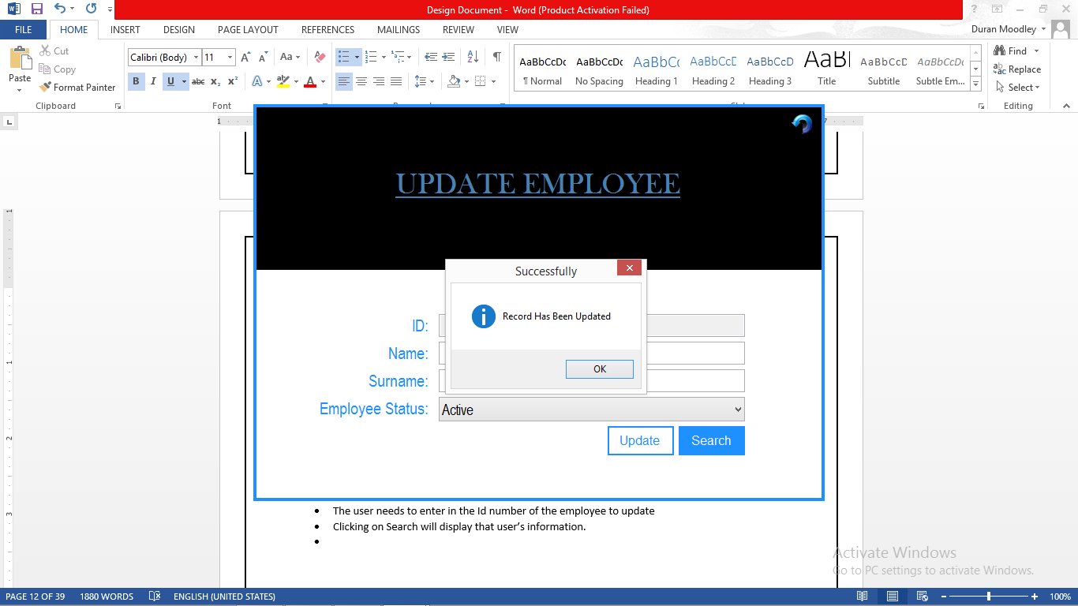

* The user can then edit any of the information of that Employee.
* Clicking on Update will change that employee’s information in the database.

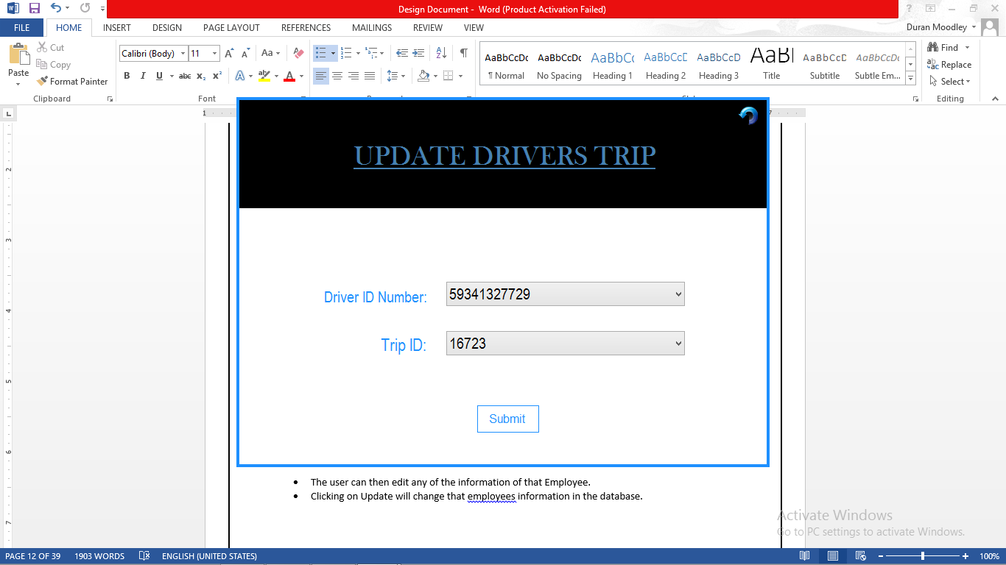

**Update Driver Trips**

* This form allows the user to select a driver in the drop down list and a Trip Id.
* Clicking Submit, will update that drivers trip in the database.

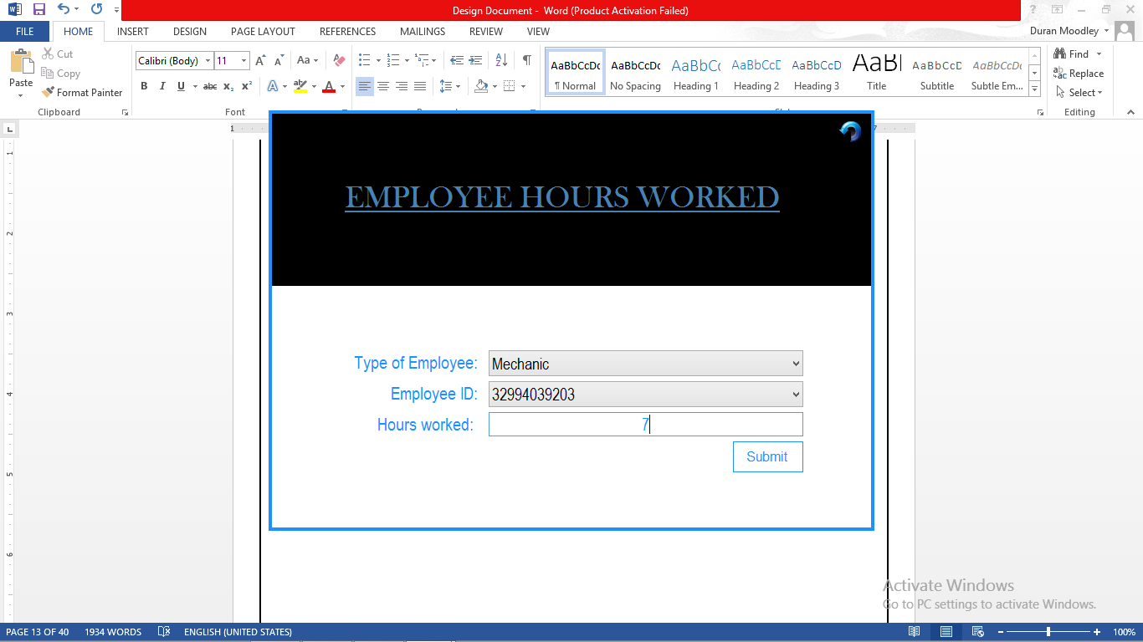

**Update Employee Hours Worked Form**

* This form updates the amount of hours that employee has worked in total.
* Clicking Submit will increment that total hours worked for that employee in the Database.

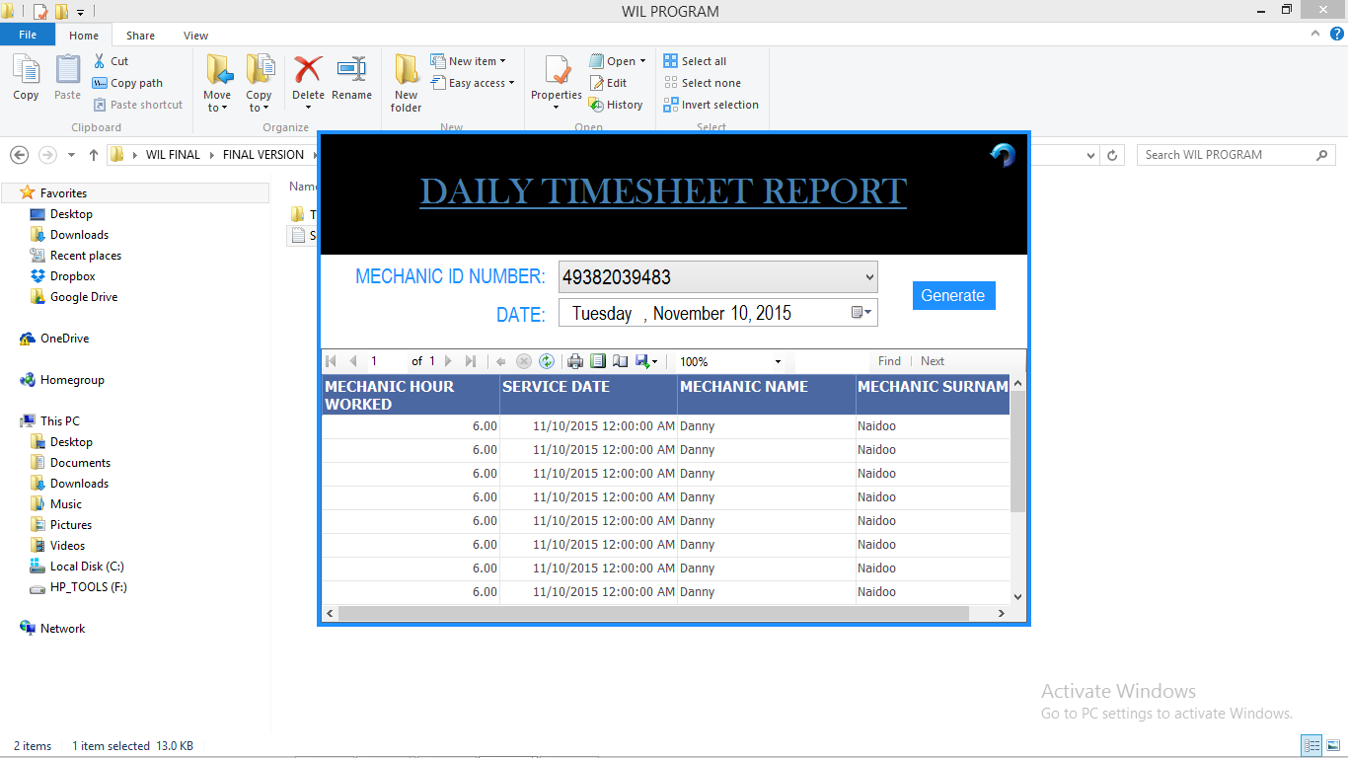

**Daily Timesheet Report for Specific Mechanic**

* The can select the specific Mechanic from the drop down list
* Thereafter he can select the day.
* Clicking generate, will search for all the times that person has worked for that day.
* This same form applies to Drivers in the business.

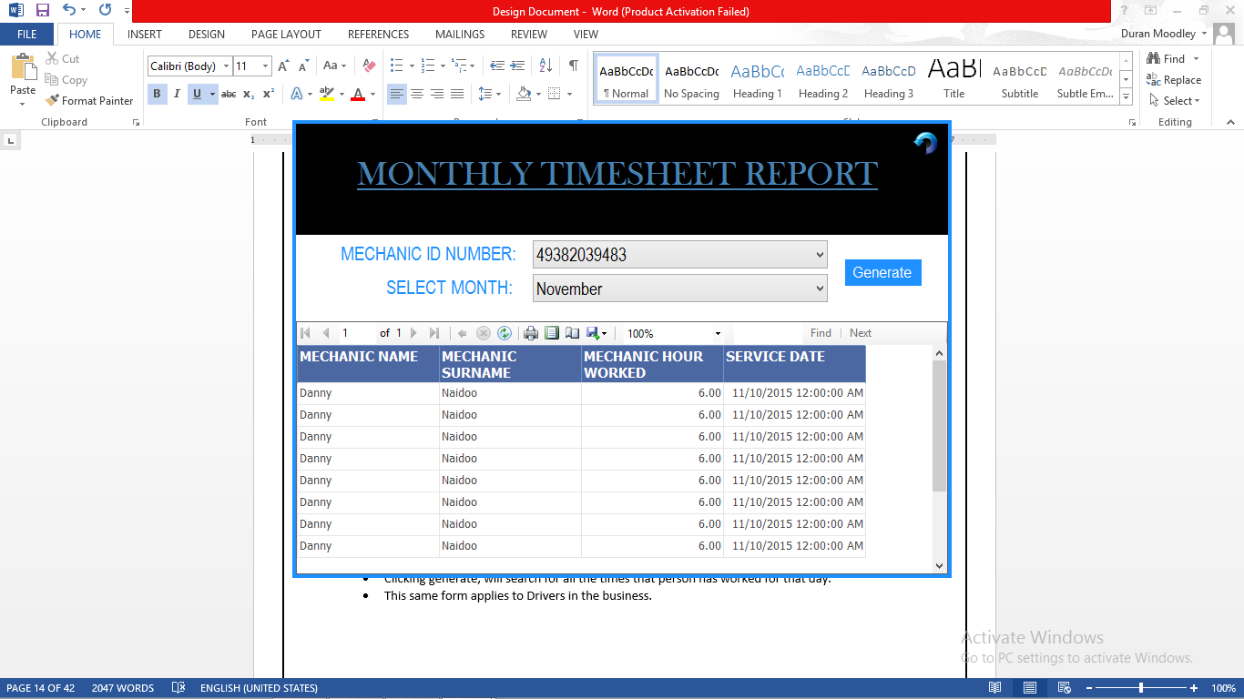

**Monthly Timesheet Report Mechanic**

* The can select the specific Mechanic from the drop down list
* Thereafter he can select the Month
* Clicking generate, will search for all the times that person has worked for that Month.
* This same form applies to Drivers in the business.

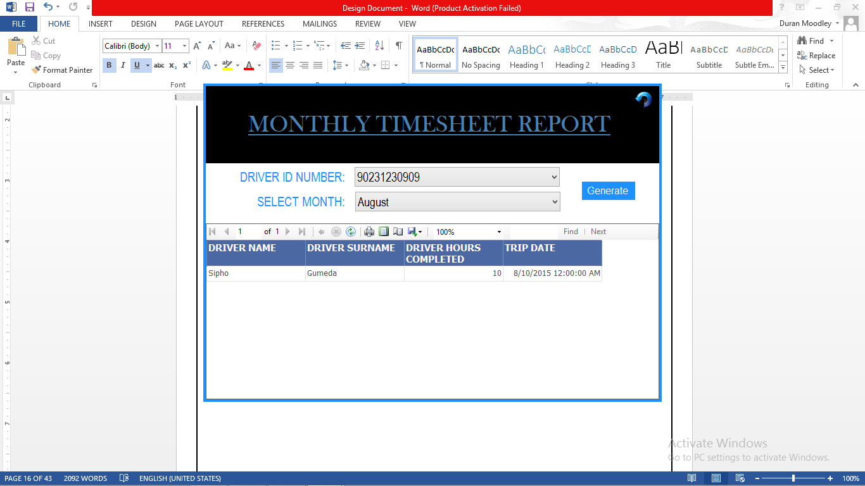

**Monthly Timesheet Report Drivers**

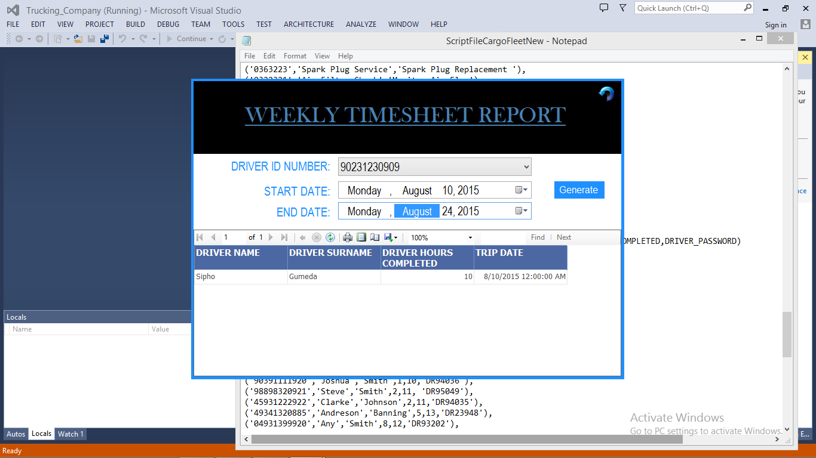

**Weekly Timesheet Driver Report**

* The User can select the driver from the drop down list.
* The user can then specify the start date and the end Date
* The Generate button, will display the report.

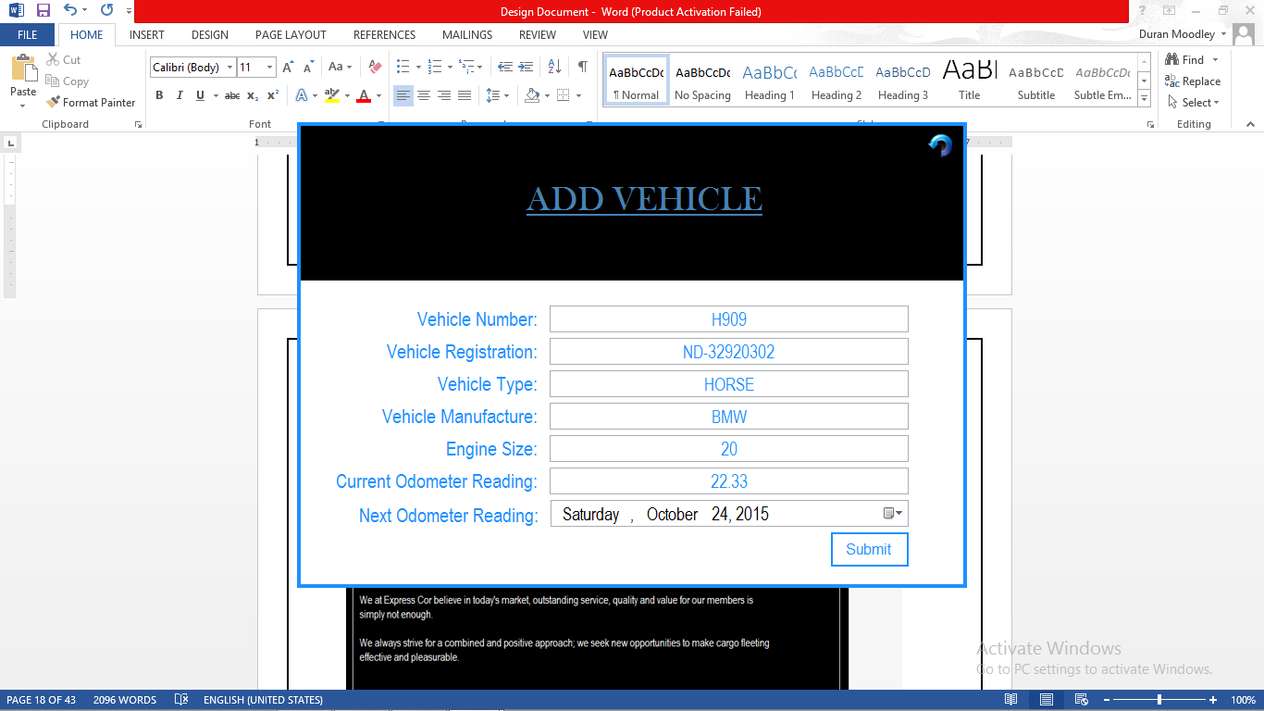

**Add Vehicle Form –** Takes in information from the controls. Clicking submit, inserts the vehicle in the database.

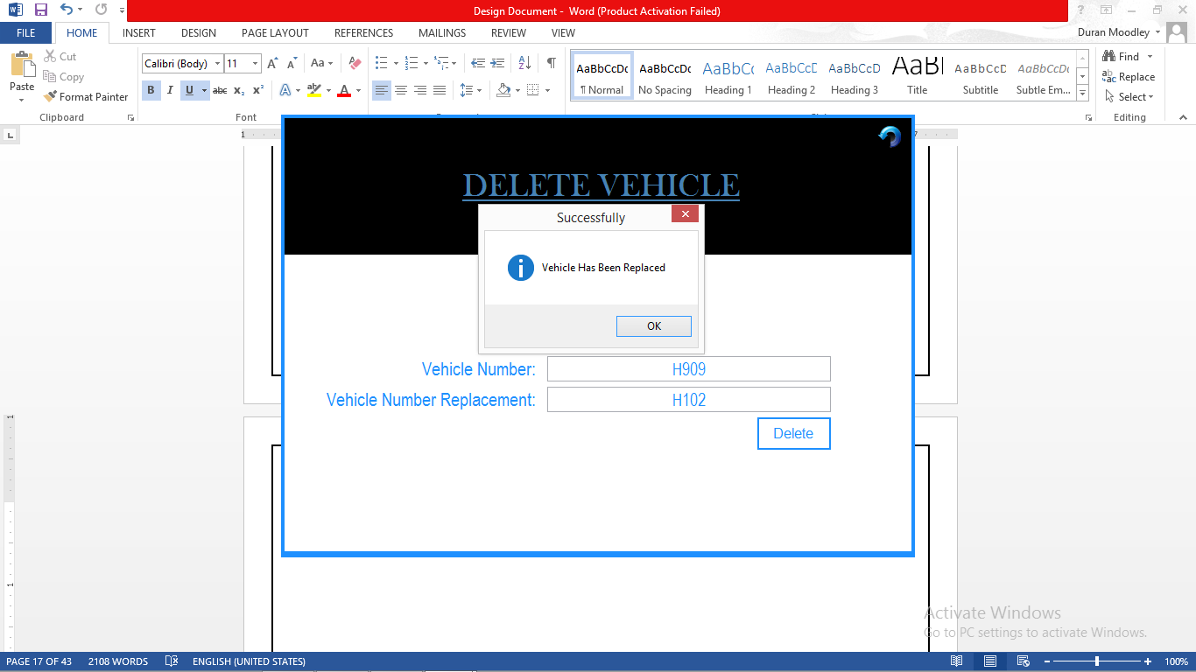

**Delete Vehicle**

* The user needs to enter the vehicle number being deleted.
* That vehicle needs to be replaced with an existing vehicle
* Clicking delete, will delete and replace that vehicle in the database

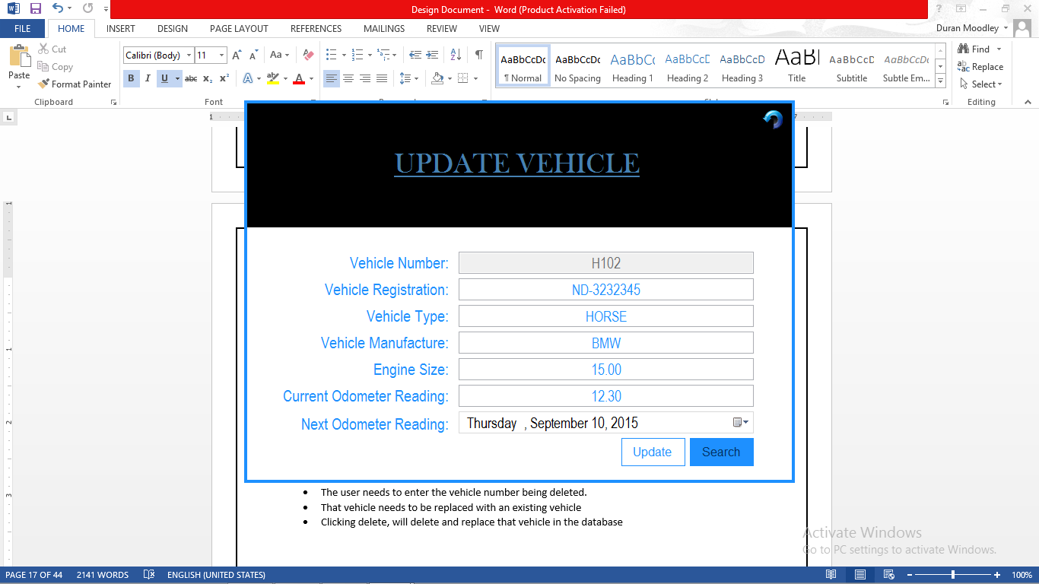

**Update Vehicle**

* This procedure is the same with the Update Employee.
* The user enters in the id number.
* Clicking search will display that vehicles details.
* Clicking on Update, will edit all details.

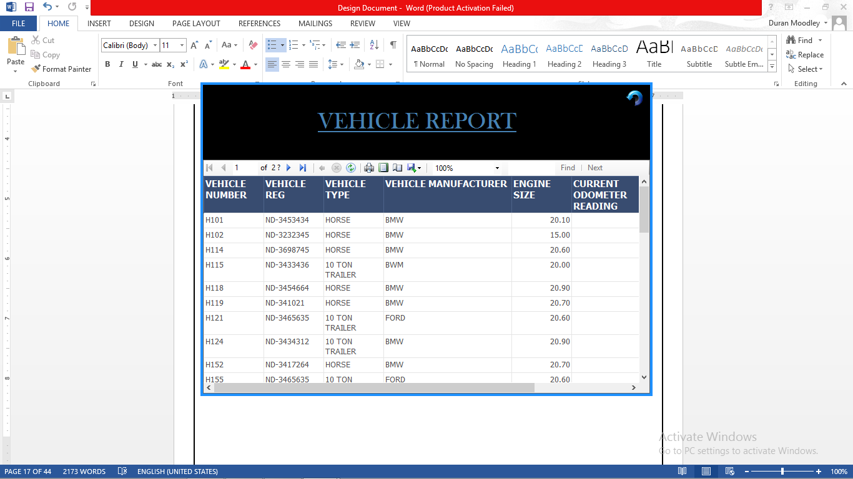

**Vehicle Report**

* Displays all vehicle information

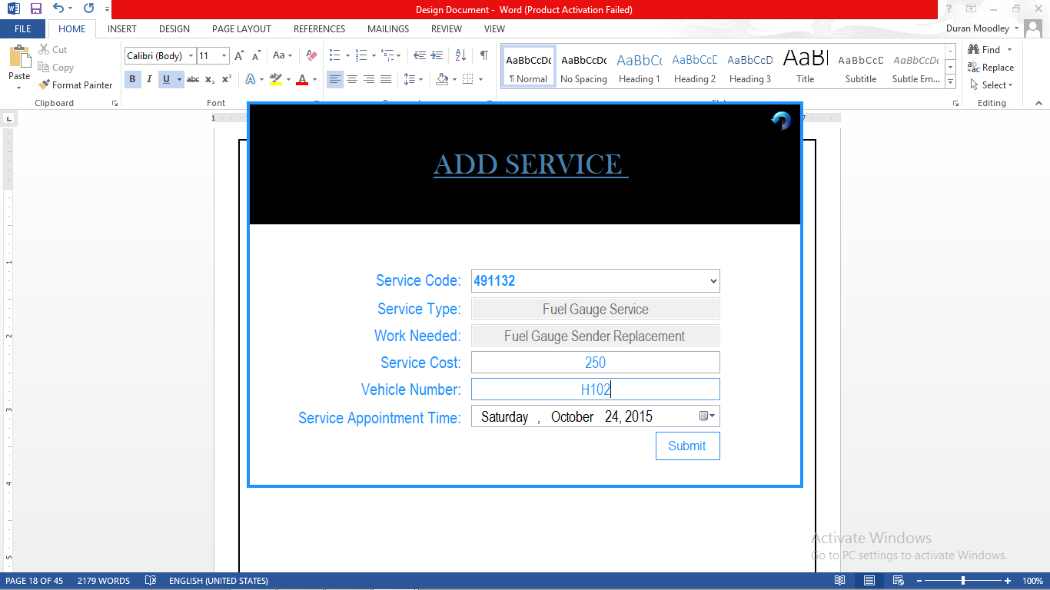

**Add Service**

* User can select the service code from the Drop down List
* Clicking Submit, will enter that service to that Vehicle in the database.

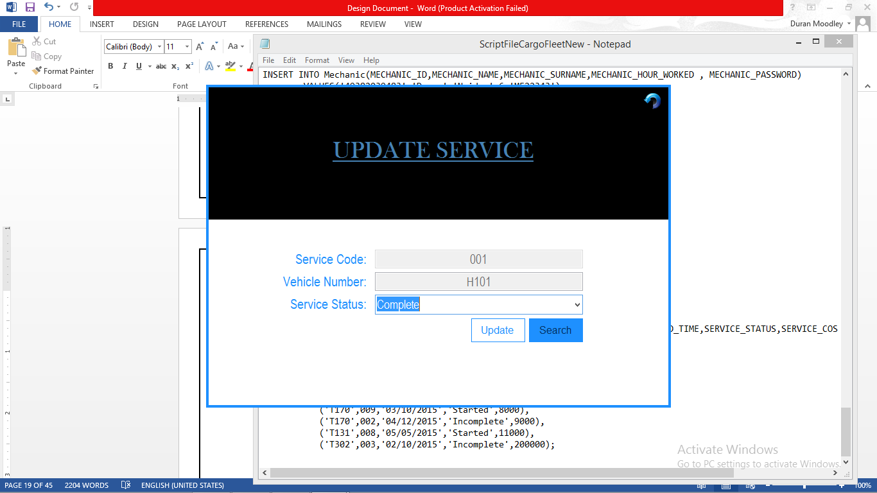

**Update Service Form**

* The user enters in the service code and the vehicle number associated with that service
* Clicking Search will bring up the current service status of the vehicle( Started, Complete, Incomplete)
* The user can then change the service status by selecting the appropriate option in the drop down list.
* The Update button will edit the vehicle service status in the database.

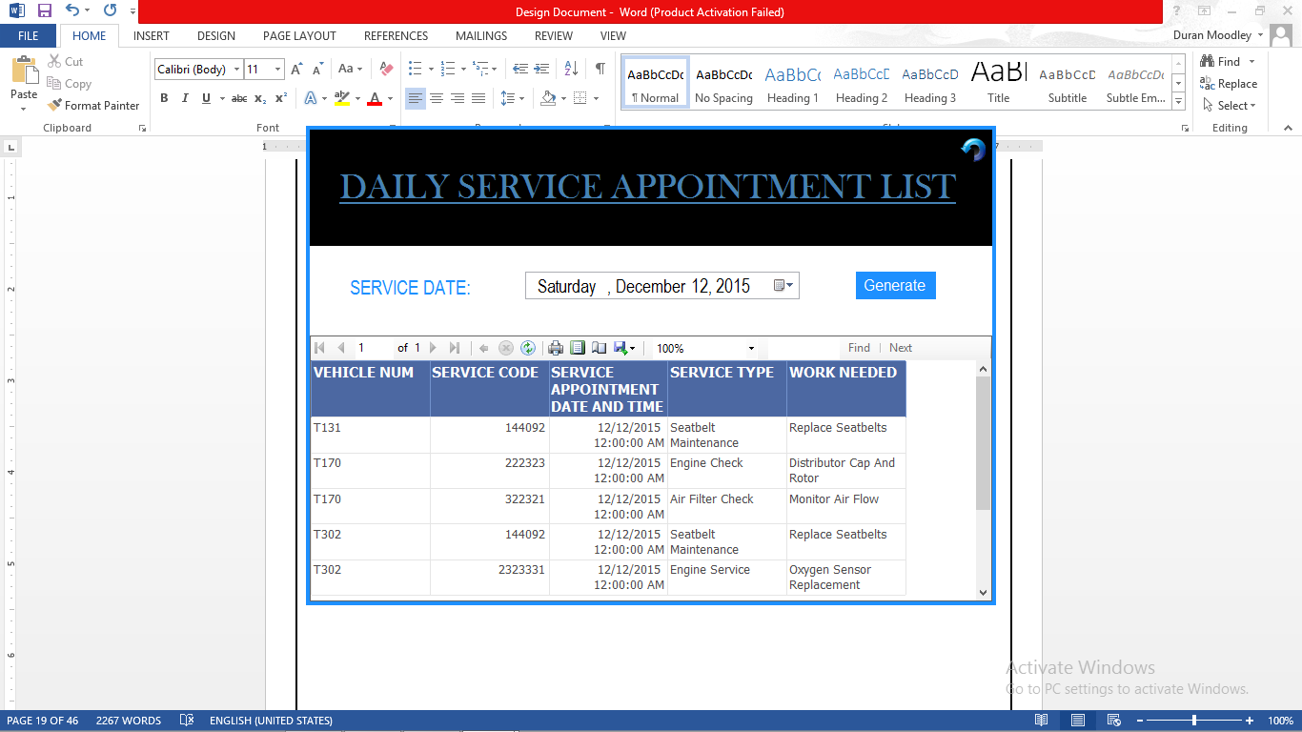

**Daily Service Appointment List**

* Clicking on Generate, will display all service appointments for specified day.

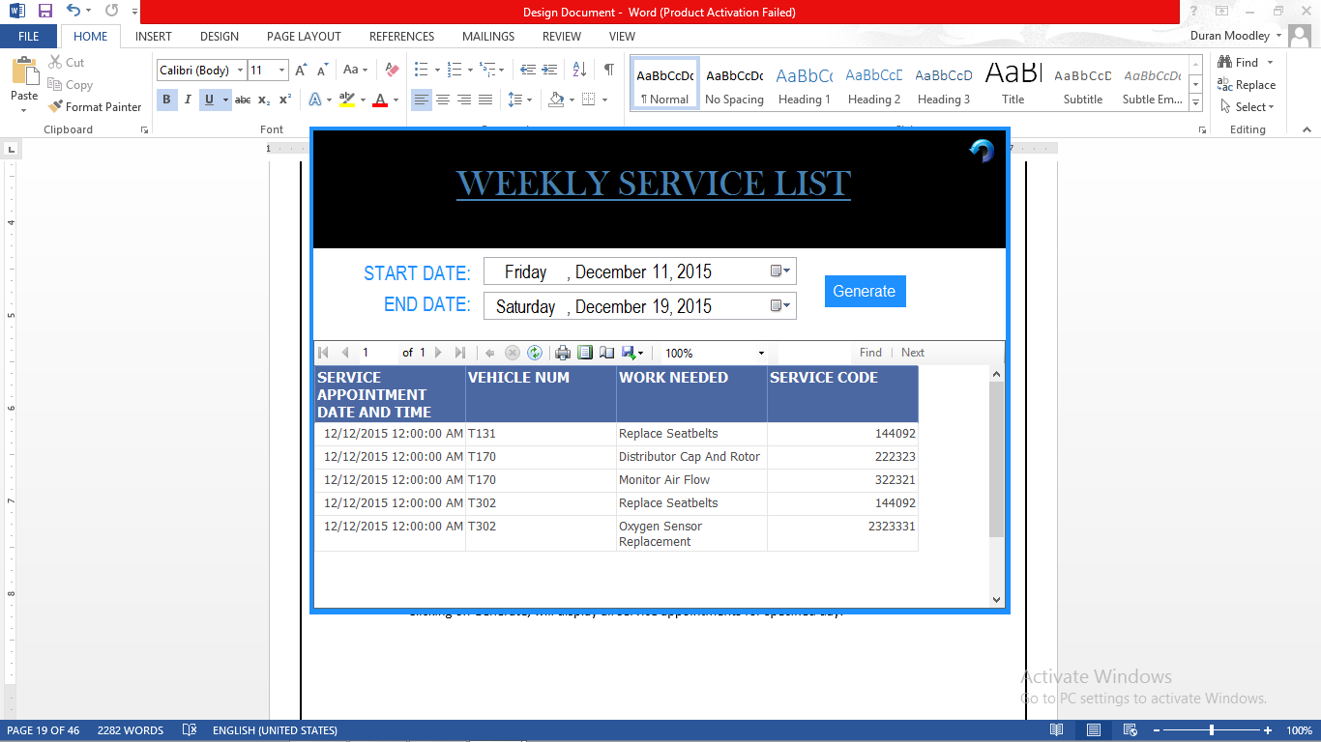

**Weekly Service Appointment List**

* The user needs to select the start date and end date.
* Clicking generate, will display all service appointments for that week.

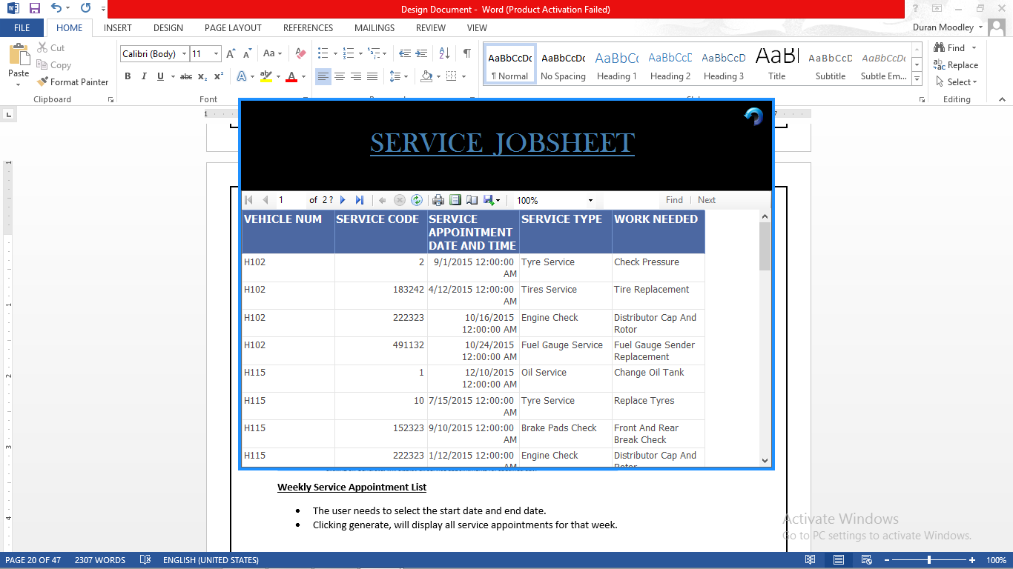

**Service Requirement Job sheet**

* Displays all services and the job requirements for that service.

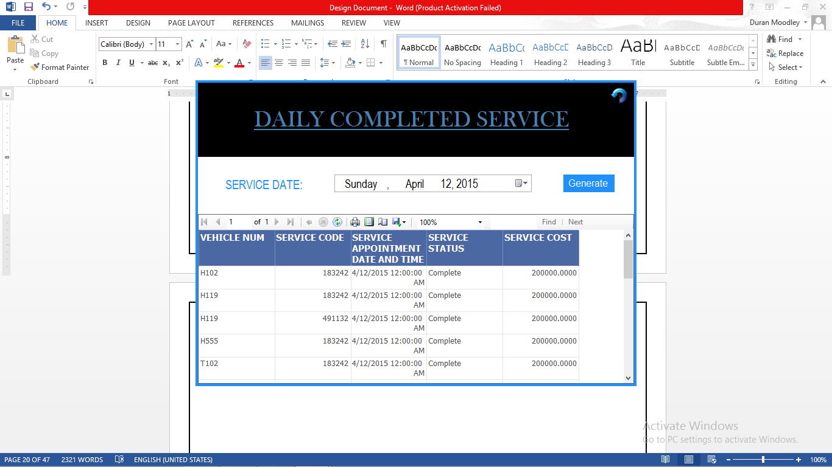

**Vehicle Service Completed Report Daily**

* The user selects a date.
* Clicking generate will display all services completed for that day.

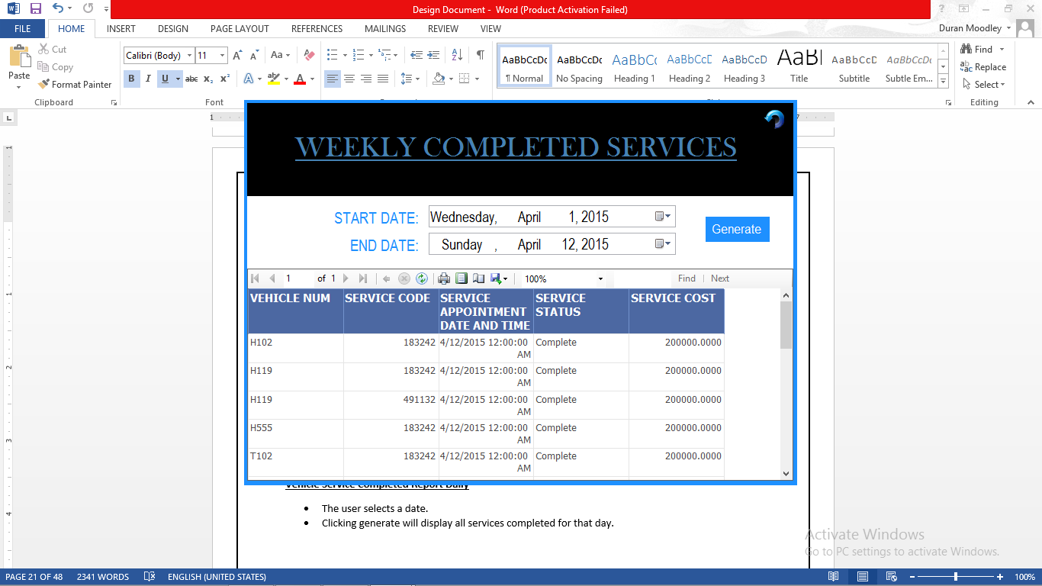

**Vehicle Services Completed Report Weekly**

* The user specifies the start date and end date.
* Clicking generate will display all completed services in that week.

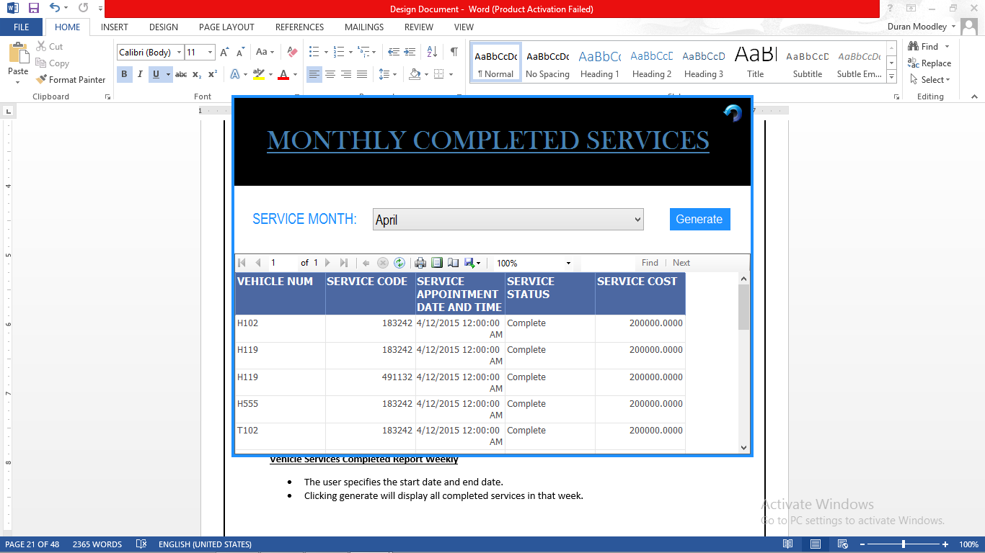 **Vehicle Service Completed Report Monthly**

* The user selects the month from the drop down list.
* Clicking generate will display all services completed in that month

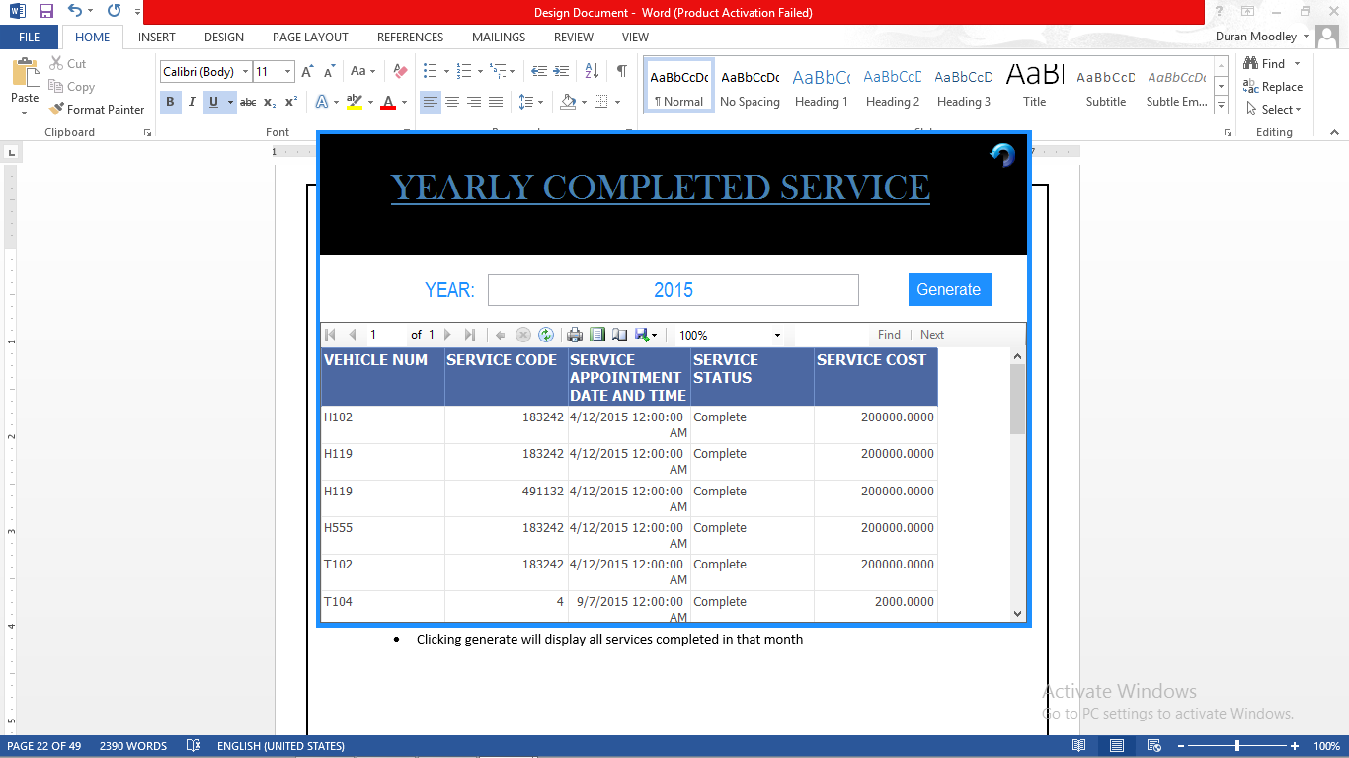

**Vehicle Services Completed Report Yearly**

* The user enters in the year.
* Clicking generate will display all services completed for that year

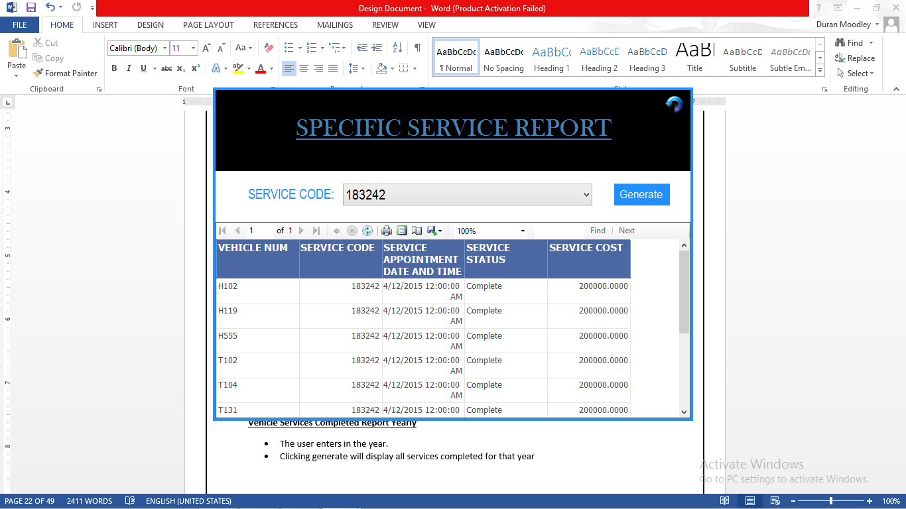

**Specific Service Report**

* The user can select the service from the drop list.
* Clicking generate will display details involving that service code.

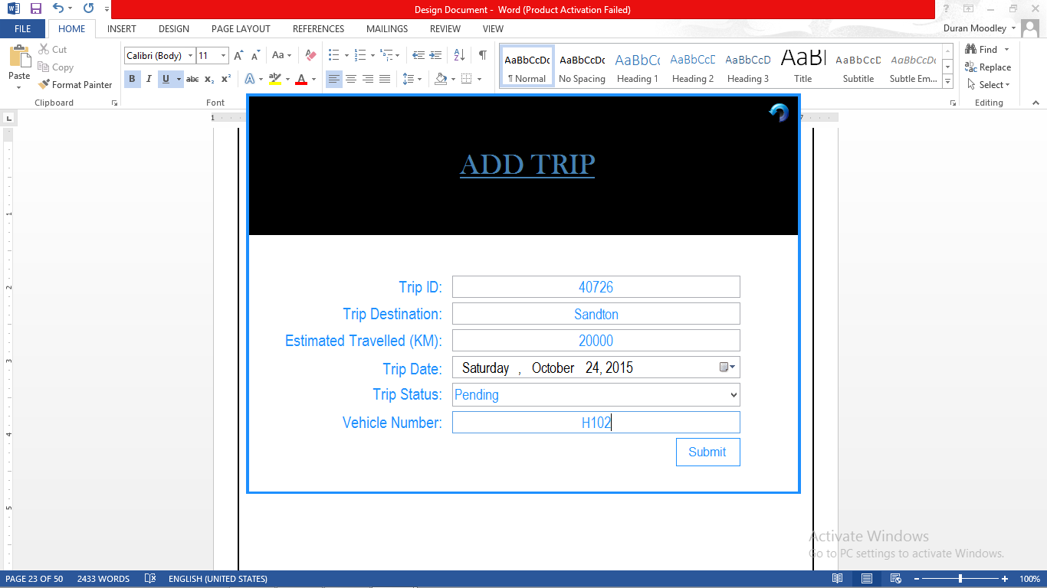

**Add Trip Form**

* A random 5 digit trip id number will be generated when the user hovers the mouse over the field
* Clicking submit will insert the details of the trip in the database

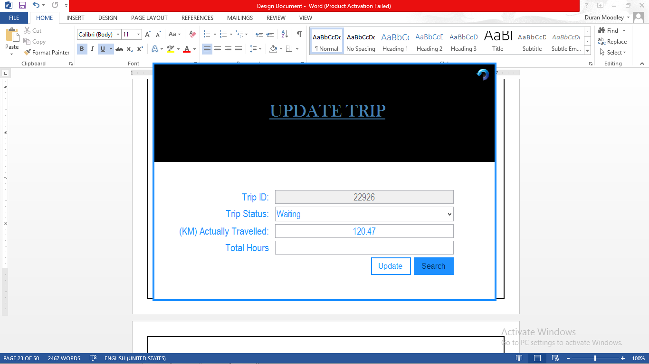

**Update Trip Form**

* The same actions to other update forms are present.
* The user enters in the trip id number
* Clicking search will display details about that trip.
* Clicking update will edit information about that trip in the database.

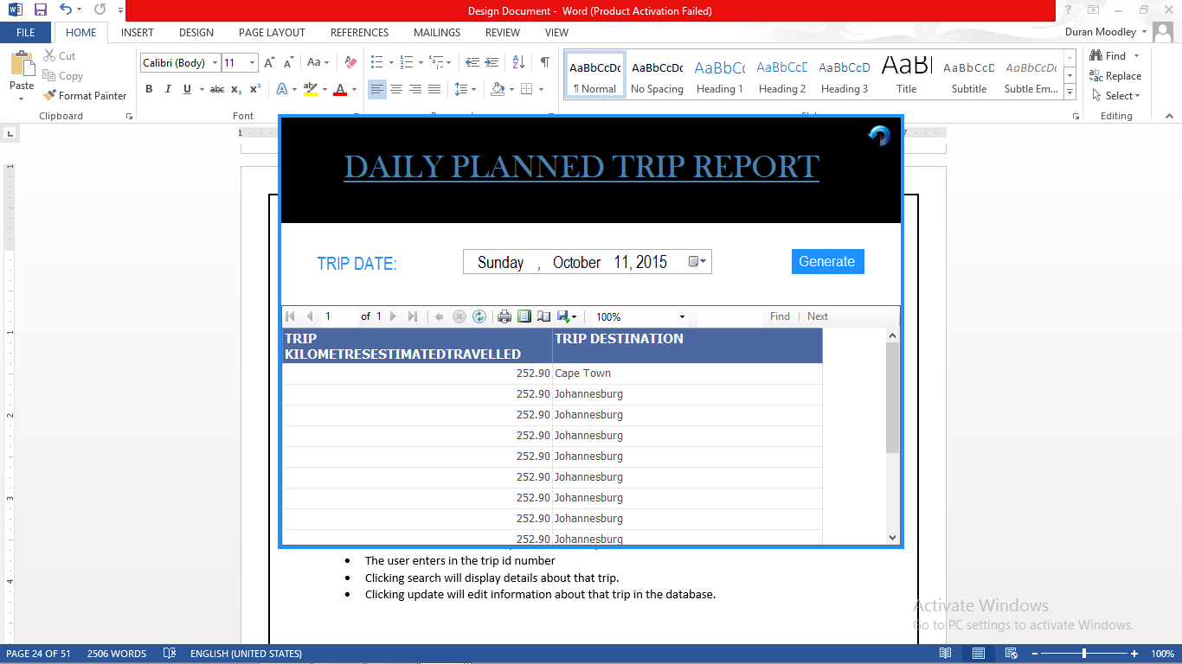

**Daily Planned Trip Report**

* The user specifies a day.
* Clicking generate will display all planned trips for that day.

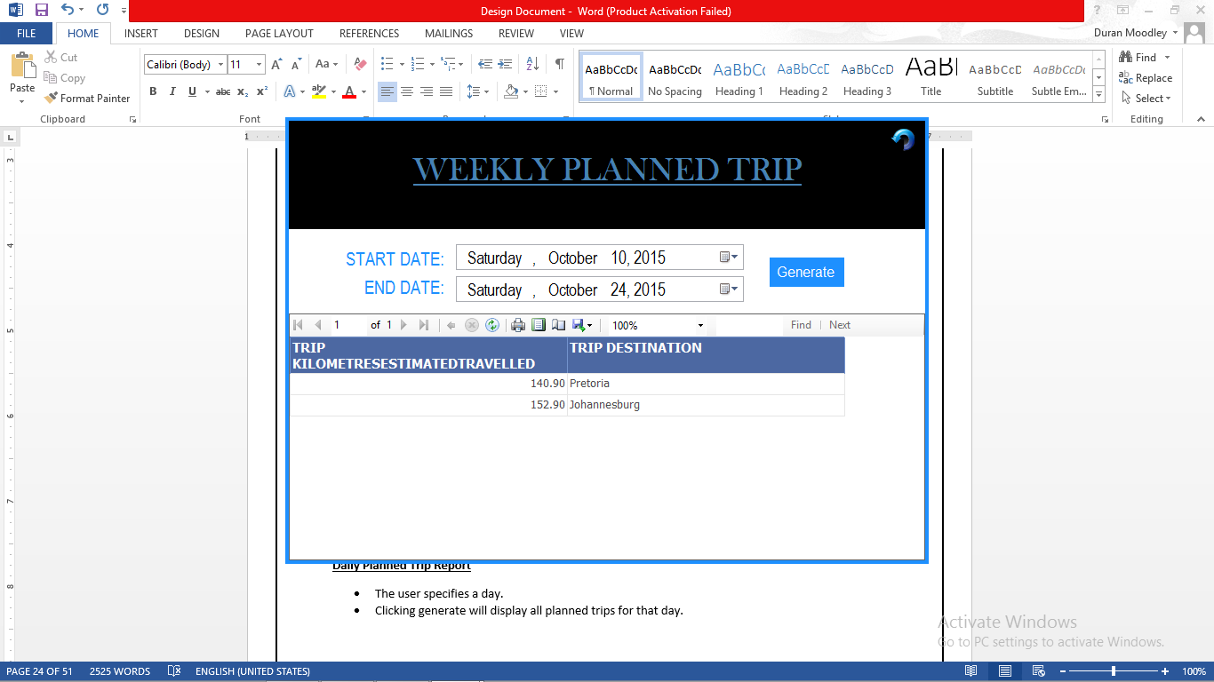

**Weekly Planned Trip Report**

* The user Specifies that start date and end date.
* Clicking on generate will display all planned trips for that week.

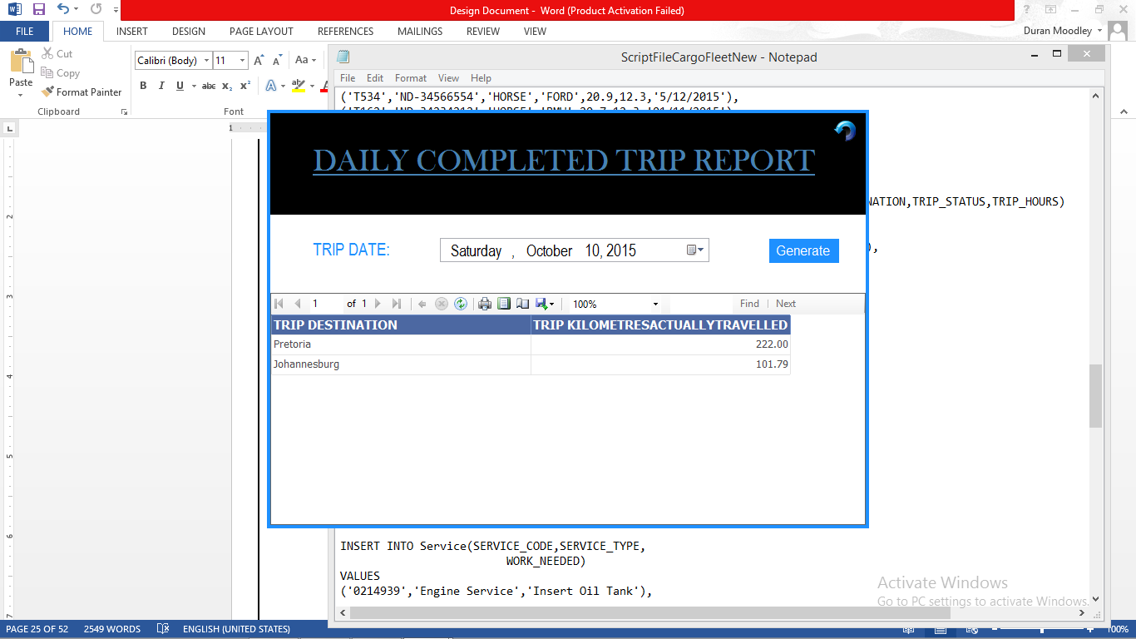  
**Daily Completed Trip Report**

* The user can specify the day.
* Clicking generate will display all completed trips for that day.

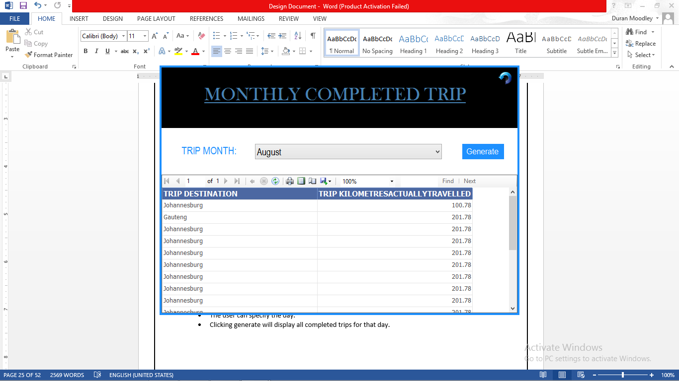

**Monthly Completed Trip Report**

* The user can select the month from the drop down list.
* Clicking generate will display all completed trips in that month.

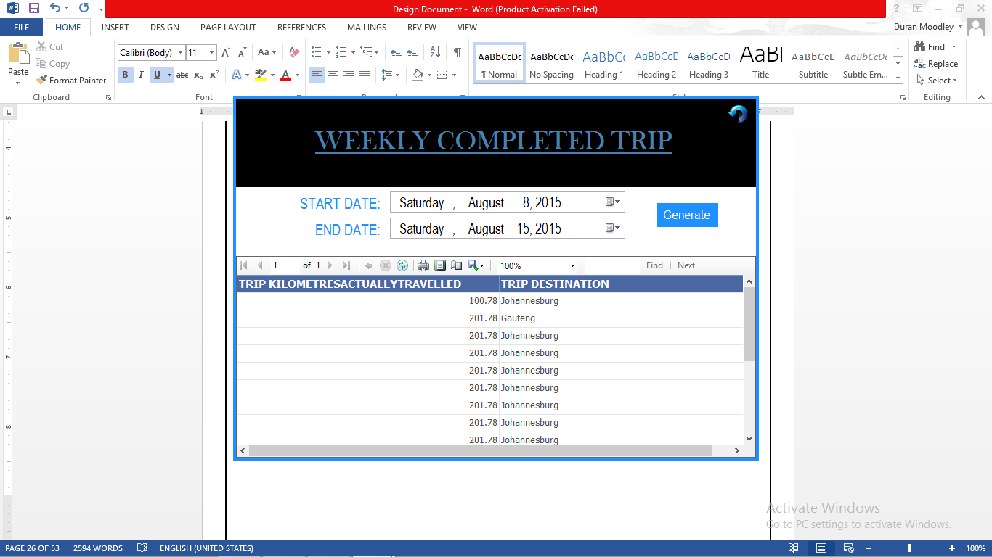

**Weekly Completed Trip Report**

* The user can specify the start date and end date.
* Clicking generate will display all completed trips in that week.

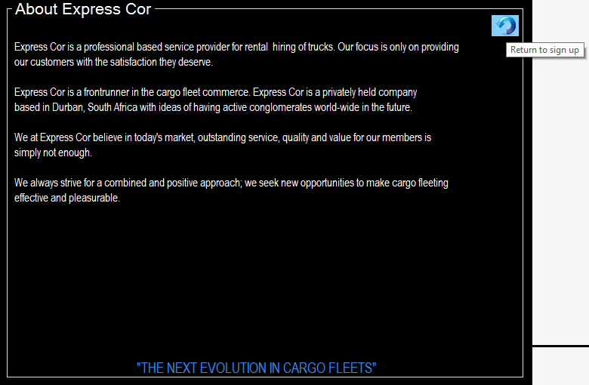

**About Form:**

Return Button -> once the user has read the info and/or would like to return back to the sign up form they may click this button.

1. **Database Design**

* 1. Database Tables

Table Name: Vehicle

Database Table 1

|  |  |  |  |  |  |  |
| --- | --- | --- | --- | --- | --- | --- |
| Primary Key | Data Fields | | | | | |
| Vehicle Number | Vehicle Reg | Vehicle Type | Vehicle Manufacturer | Engine Size | Current Odometer Reading | Next Service Odometer Reading |
| H101 | ND-32939239 | Horse | BMW | 20 | 33.33 | 12/10/2015 |
| T102 | ND-39203021 | 10 Ton Trailer | Ford | 30 | 22.22 | 15/10/2015 |
| H122 | ND-29939293 | Horse | Ford | 20 | 23.22 | 20/10/2015 |

Table Name: Employee

Database Table 2

|  |  |  |  |  |  |  |  |
| --- | --- | --- | --- | --- | --- | --- | --- |
| Primary Key | Data Fields | | | | | |  |
| Employee ID | Employee First Name | Employee Last Name | Employee Title | Employee User | | Employee Password | Employee Status |
| 06967543254 | Jon | Hutch | Vehicle Administrator | Happy | VE26034 | | Disable |
| 37483723847 | Kal | singh | Officer Manager | kal | OF52675 | | Active |
| 27384930493 | Kalvin | Smith | Officer Manager | kel | OF66355 | | Active |

Table Name: Trip

Database Table 3

|  |  |  |  |  |  |  |  |  |  |  |  |  |  |
| --- | --- | --- | --- | --- | --- | --- | --- | --- | --- | --- | --- | --- | --- |
| Primary Key | Data Fields | | | | | | | | | | |  | |
| Trip ID | Vehicle  Number {FK} | | Trip Kilometer Actually Traveled | Trip Estimated Kilometers Traveled | | Trip Date | | Trip Destination | | Trip Status | | Trip Hours | |
| 00008 | | H101 | 1000 | | 1500 | | 8/10/2015 | | Johannesburg | | Completed | | 15 | |
| 00009 | | T102 | 3500 | | 3400 | | 8/10/2015 | | Cape Town | | Waiting | | 18 | |
| 00010 | | H122 | 8000 | | 7000 | | 9/12/2015 | | Sandton | | Dispatched | | 19 | |

Table Name: Services

Database Table 4

|  |  |  |
| --- | --- | --- |
| Primary Key | Data Fields | |
| Service Code | Service Type | Work Needed |
| 1029302 | Oil Service | Change Oil |
| 1939203 | Tyre Service | Change Tyre |
| 2939203 | Engine Service | Check heat gauge |

Table Name: Drivers

Database Table 5

|  |  |  |  |  |  |
| --- | --- | --- | --- | --- | --- |
| Primary Key | Data Fields | | | | |
|
| Driver ID | Driver Name | Driver Surname | Trip ID{FK} | Driver Hours Completed | Driver Password |
| 03889788990 | Clive | Naicker | 00008 | 10 | DR25298 |
| 04931323920 | Any | Smith | 00009 | 15 | DR93202 |
| 04931399920 | Manual | Jenner | 00010 | 10 | DR26354 |

Table Name: Mechanic

Database Table 6

|  |  |  |  |  |
| --- | --- | --- | --- | --- |
| Primary Key | Data Fields | | | |
| Unique Mechanic ID | Mechanic  Name | Mechanic  Surname | Mechanic  Hours Completed | Mechanic Password |
| 23159403909 | Danny | Naido | 5 | ME10343 | |
| 32994039203 | John | Smith | 15 | ME12232 | |
| 49382039483 | Mphilo | Lunda | 10.00 | ME12378 | |

Table Name: Vehicle Services

Database Table 7

|  |  |  |  |  |
| --- | --- | --- | --- | --- |
| Primary Key | | Data Fields | | |
| Vehicle_  Number | **Service Code** | Service Date | Service Status | Service Cost |
| H101 | **1029302** | 2015-09-01 00:00:00.000 | Started | 798.00 |
| T102 | **1939203** | 2015-04-12 00:00:00.000 | Complete | 6000.00 |
| H115 | **1029302** | 2015-07-15 00:00:00.000 | Started | 10000.00 |

Table Name: Mechanic Services

Database Table 8

|  |  |  |
| --- | --- | --- |
| Primary Key | | Data Fields |
| Mechanic  ID Number | **Service Code** | Service Date |
| 12343238899 | **1029302** | 2015-05-05 00:00:00.000 |
| 14545438998 | **1939203** | 2015-11-10 00:00:00.000 |
| 49382039483 | **1029302** | 2015-08-03 00:00:00.000 |

* 1. ERD Design





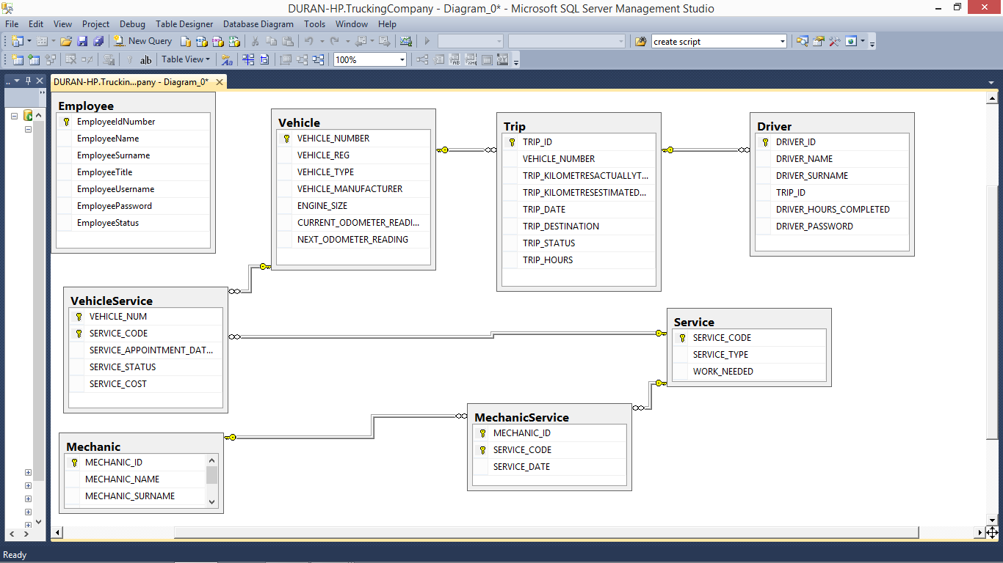

1. **Report Design**

**Printed report #1: Vehicle Status Report**

|  |  |  |  |  |  |  |
| --- | --- | --- | --- | --- | --- | --- |
| **VEHICLE NUMBER** | **VEHICLE REG** | **VEHICLE TYPE** | **VEHICLE MANUFACTURER** | **ENGINE SIZE** | **CURRENT ODOMETER READING** | **NEXT ODOMETER READING** |
| H101 | ND-3453434 | HORSE | BMW | 20.10 | 12.30 | 8/10/2015 12:00:00 AM |
| H102 | ND-3232345 | HORSE | BMW | 15.00 | 12.30 | 9/10/2015 12:00:00 AM |
| H114 | ND-3698745 | HORSE | BMW | 20.60 | 12.90 | 2/11/2015 12:00:00 AM |
| H115 | ND-3433436 | 10 TON TRAILER | BWM | 20.00 | 12.30 | 10/10/2015 12:00:00 AM |
| H118 | ND-3454664 | HORSE | BMW | 20.90 | 12.30 | 6/10/2015 12:00:00 AM |
| H119 | ND-341021 | HORSE | BMW | 20.70 | 12.90 | 9/6/2015 12:00:00 AM |
| H121 | ND-3465635 | 10 TON TRAILER | FORD | 20.60 | 129.00 | 12/3/2015 12:00:00 AM |
| H124 | ND-3434312 | 10 TON TRAILER | BMW | 20.90 | 12.30 | 8/11/2015 12:00:00 AM |
| H152 | ND-3417264 | HORSE | BMW | 20.70 | 12.90 | 7/6/2015 12:00:00 AM |
| H155 | ND-3465635 | 10 TON TRAILER | FORD | 20.60 | 129.00 | 6/7/2015 12:00:00 AM |

**Printed report #2: Daily Service Appointment list**

|  |  |  |  |  |
| --- | --- | --- | --- | --- |
| **VEHICLE NUM** | **SERVICE CODE** | **SERVICE APPOINTMENT DATE AND TIME** | **SERVICE TYPE** | **WORK NEEDED** |
| T131 | 144092 | 12/12/2015 12:00:00 AM | Seatbelt Maintenance | Replace Seatbelts |
| T170 | 222323 | 12/12/2015 12:00:00 AM | Engine Check | Distributor Cap And Rotor |
| T170 | 322321 | 12/12/2015 12:00:00 AM | Air Filter Check | Monitor Air Flow |
| T302 | 144092 | 12/12/2015 12:00:00 AM | Seatbelt Maintenance | Replace Seatbelts |
| T302 | 2323331 | 12/12/2015 12:00:00 AM | Engine Service | Oxygen Sensor Replacement |

**Weekly Service Appointment list**

|  |  |  |  |
| --- | --- | --- | --- |
| **SERVICE APPOINTMENT DATE AND TIME** | **VEHICLE NUM** | **WORK NEEDED** | **SERVICE CODE** |
| 12/10/2015 12:00:00 AM | H115 | Change Oil Tank | 1 |
| 12/12/2015 12:00:00 AM | T131 | Replace Seatbelts | 144092 |
| 12/12/2015 12:00:00 AM | T170 | Distributor Cap And Rotor | 222323 |
| 12/12/2015 12:00:00 AM | T170 | Monitor Air Flow | 322321 |
| 12/12/2015 12:00:00 AM | T302 | Replace Seatbelts | 144092 |
| 12/12/2015 12:00:00 AM | T302 | Oxygen Sensor Replacement | 2323331 |

**Printed report #3: Service Requirements Job Sheet**

|  |  |  |  |  |
| --- | --- | --- | --- | --- |
| **VEHICLE NUM** | **SERVICE CODE** | **SERVICE APPOINTMENT DATE AND TIME** | **SERVICE TYPE** | **WORK NEEDED** |
| H102 | 2 | 9/1/2015 12:00:00 AM | Tyre Service | Check Pressure |
| H102 | 183242 | 4/12/2015 12:00:00 AM | Tires Service | Tire Replacement |
| H102 | 222323 | 10/16/2015 12:00:00 AM | Engine Check | Distributor Cap And Rotor |
| H115 | 1 | 12/10/2015 12:00:00 AM | Oil Service | Change Oil Tank |
| H115 | 10 | 7/15/2015 12:00:00 AM | Tyre Service | Replace Tyres |
| H115 | 152323 | 9/10/2015 12:00:00 AM | Brake Pads Check | Front And Rear Break Check |
| H115 | 222323 | 1/12/2015 12:00:00 AM | Engine Check | Distributor Cap And Rotor |
| H119 | 183242 | 4/12/2015 12:00:00 AM | Tires Service | Tire Replacement |

**Printed report #4: Daily/Weekly/Monthly/Yearly Vehicle Service Complete Report**

|  |  |  |  |  |
| --- | --- | --- | --- | --- |
| **VEHICLE NUM** | **SERVICE CODE** | **SERVICE APPOINTMENT DATE AND TIME** | **SERVICE STATUS** | **SERVICE COST** |
| H102 | 183242 | 4/12/2015 12:00:00 AM | Complete | 200000.0000 |
| H119 | 183242 | 4/12/2015 12:00:00 AM | Complete | 200000.0000 |
| H119 | 491132 | 4/12/2015 12:00:00 AM | Complete | 200000.0000 |
| H555 | 183242 | 4/12/2015 12:00:00 AM | Complete | 200000.0000 |
| T102 | 183242 | 4/12/2015 12:00:00 AM | Complete | 200000.0000 |
| T104 | 183242 | 4/12/2015 12:00:00 AM | Complete | 200000.0000 |
| T131 | 152323 | 4/12/2015 12:00:00 AM | Complete | 200000.0000 |

**Printed report #5: Specific Service Report**

|  |  |  |  |  |  |  |  |  |  |  |  |  |  |  |  |  |  |  |  |  |  |  |  |  |  |  |  |  |  |  |  |  |  |  |  |  |  |  |  |  |  |  |  |  |  |
| --- | --- | --- | --- | --- | --- | --- | --- | --- | --- | --- | --- | --- | --- | --- | --- | --- | --- | --- | --- | --- | --- | --- | --- | --- | --- | --- | --- | --- | --- | --- | --- | --- | --- | --- | --- | --- | --- | --- | --- | --- | --- | --- | --- | --- | --- |
| |  |  |  |  |  | | --- | --- | --- | --- | --- | | **VEHICLE NUM** | **SERVICE CODE** | **SERVICE APPOINTMENT DATE AND TIME** | **SERVICE STATUS** | **SERVICE COST** | | H102 | 183242 | 4/12/2015 12:00:00 AM | Complete | 200000.0000 | | H119 | 183242 | 4/12/2015 12:00:00 AM | Complete | 200000.0000 | | H555 | 183242 | 4/12/2015 12:00:00 AM | Complete | 200000.0000 | | T102 | 183242 | 4/12/2015 12:00:00 AM | Complete | 200000.0000 | | T104 | 183242 | 4/12/2015 12:00:00 AM | Complete | 200000.0000 | | T131 | 183242 | 4/12/2015 12:00:00 AM | Complete | 200000.0000 | | T170 | 183242 | 4/12/2015 12:00:00 AM | Complete | 200000.0000 | | T302 | 183242 | 4/12/2015 12:00:00 AM | Complete | 200000.0000 | |

**Printed report #6: Daily/Weekly Planned trip Report**

|  |  |  |  |  |  |  |  |  |  |  |  |  |  |  |  |  |  |  |  |  |
| --- | --- | --- | --- | --- | --- | --- | --- | --- | --- | --- | --- | --- | --- | --- | --- | --- | --- | --- | --- | --- |
| |  |  | | --- | --- | | **TRIP KILOMETRESESTIMATEDTRAVELLED** | **TRIP DESTINATION** | | 252.90 | Cape Town | | 252.90 | Johannesburg | | 252.90 | Johannesburg | | 252.90 | Johannesburg | | 252.90 | Johannesburg | | 252.90 | Johannesburg | | 252.90 | Johannesburg | | 252.90 | Johannesburg | | 252.90 | Johannesburg | |

**Printed report #7: Daily/Weekly/Monthly completed trip Report**

|  |  |
| --- | --- |
| **TRIP DESTINATION** | **TRIP KILOMETRESACTUALLYTRAVELLED** |
| Johannesburg | 100.78 |
| Gauteng | 201.78 |
| Johannesburg | 201.78 |
| Johannesburg | 201.78 |
| Johannesburg | 201.78 |
| Johannesburg | 201.78 |
| Johannesburg | 201.78 |
| Johannesburg | 201.78 |
| Johannesburg | 201.78 |
| Johannesburg | 201.78 |
| Johannesburg | 201.78 |
| Johannesburg | 100.78 |
| Gauteng | 201.78 |
| Johannesburg | 201.78 |

**Printed report #8: Daily/Weekly/Monthly Time sheet Report**

|  |  |  |  |  |  |  |  |  |  |  |  |  |  |  |  |  |  |  |  |  |  |  |  |  |
| --- | --- | --- | --- | --- | --- | --- | --- | --- | --- | --- | --- | --- | --- | --- | --- | --- | --- | --- | --- | --- | --- | --- | --- | --- |
| |  |  |  |  | | --- | --- | --- | --- | | **MECHANIC NAME** | **MECHANIC SURNAME** | **MECHANIC HOUR WORKED** | **SERVICE DATE** | | Dave | Schoeeman | 14.00 | 5/5/2015 12:00:00 AM | | Dave | Schoeeman | 20 | 5/5/201512:00:00 AM | | Dave | Schoeeman | 14.00 | 20/5/2015 12:00:00 AM | | Dave | Schoeeman | 20 | 22/5/2015 12:00:00 AM | | Dave | Schoeeman | 6 | 28/5/2015 12:00:00 AM | |
|  |

1. **Appendix B**

*In order for the business to use the program, Microsoft SQL Server needs to be installed on the computers of the company*.

*When a vehicle is deleted. The trips that are associated with that vehicle need to be replaced with another existing vehicle. Therefore, deleting a vehicle means not only deleting it from the vehicle table but also in the vehicle service table and trip table.*

# MINUTES

Meeting Minutes (Unofficial Meeting)

6 May 2015

|  |  |
| --- | --- |
| Present:  Absentees: Priyen , Harmsworth | Duran, Mishka, Lunga |
| Next meeting: | May 7, 2015, 13:20 |

Start Time: 13:20

Finish Time: 13:45

**Discussion**

* Brief Introduction to the project plan
* Read the problem statement

**Next Meeting Topics**

* Discuss Project Plan in details
* Assign further tasks to group members

Meeting Minutes

7 May 2010

|  |  |
| --- | --- |
| Present:  Absentees: | Duran, Mishka, Lunga  Priyen, Harmsworth |
| Next meeting: | May 13, 2015, 13:20 |

Start Time: 13:20

Finish Time: 13:45

**Discussion**

* A decision was made to make a desktop application
* Discussed the project plan in details
* Planning a meeting with business representative to get actual test data
* Brainstormed ideas about how to solve the problem

**Next Meeting Topics**

* Discuss Project Plan in details
* Assign further tasks to group members

Meeting Minutes

14 May 2015

|  |  |
| --- | --- |
| Present:  Absentees: | Duran, Mishka, Lunga  Priyen, Harmsworth |
| Next meeting: | May 20, 2015 |

Start Time: 13:00

Finish Time: 13:20

**Discussion**

* Discussed the project plan in details like the structure of the document, the introduction, milestones and deliverables, Risk Management.
* Explained all the requirements for the project plan which is clearly explained in the WILL Text book
* Set deadlines for all tasks ( 20 February)
* Assigned tasks to group members
  + Harmsworth – Risk Management
  + Mishka – Economic feasibility
  + Priyen – Gant Charts
  + Lunga Technical Feasibility

**Next Meeting Topics**

* Discuss the requirements for the Analysis phase
* Fix up the project plan
* Split tasks amongst group members

Meeting Minutes

20 May 2015

|  |  |
| --- | --- |
| Present:  Absentees: Lunga, Harmsworth | Duran, Mishka, Priyen, |
| Next meeting: | May 26, 2015, 12:30 |

Start Time: 12:15

Finish Time: 13:00

**Discussion**

* Discussed further tasks and due dates of tasks
* Discussed the project plan final requirements
  + Cvs
  + Update Gantt Chart and project schedules
  + Group Member photos
  + Redo Technical Feasibility
* Planning a meeting with business representative to get actual test data. Scheduled for 23rd to 24th of May.
* Discussed team member requirements. E.g. CVs

**Next Meeting Topics**

* Discuss further details of ideas and solutions for our project.
* Assign further tasks to group members with responsibilities.

Meeting Minutes

26 May 2015

|  |  |
| --- | --- |
| Present:  Absentees: Priyen, Lunga | Duran, Mishka, Hutch(NEW GROUP MEMBER) ,Harmsworth |
| Next meeting: | May 29, 2015, 12:30 |

Start Time: 12:30

Finish Time: 13:00

**Discussion**

* Discussed the requirements analysis in great details.
  + Structure of the document
  + Functional Requirements
  + Class Diagrams
  + ERD
* Briefed new Task member of the our current progress and issued him two task
  + Complete Technical Feasibility
  + Functional Requirements
* Assigned new Tasks to all members
  + Lunga – Designing the structure of the document
  + Mishka – Problem Domain
  + Priyen – Class Diagrams
  + Harmworth – Logical System requirements
* Group Leader gave guidance on how to handle the tasks

**Next Meeting Topics**

* Discuss issues with the Requirements analysis
* Start planning and discussing Design Document
* Assign further tasks to group members with responsibilities.

Meeting Minutes

29 May 2015

|  |  |
| --- | --- |
| Present:  Absentees: Priyen | Duran, Mishka, Lunga  Harmsworth |
| Next meeting: | June 5, 2015 |

Start Time: 14:00

Finish Time: 14:20

**Discussion**

* Discussed current progress of documentation. Project plan is near completion ,however, requirements analysis needs improvement.
* A new rule was announced: **Any Team Member who does not submit in a specified task on the specified deadline will be receiving a warning.**
* New tasks were assigned to all group members
  + Hutch – Database Design (Page 54)
  + Harmsworth – Low Level Architectural Design (page 51)
  + Priyen – The Input Interactions (page 52)
  + Lunga – Introduction ( page 50)
  + Mishka – Report Design (Bottom of page 55-56)
* Priyen has not attended 4 meetings. Action will be taken. A private meeting with him will be conducted.

**Next Meeting Topics**

* Finalize all classes that will be used in the program
* Finalize database tables within our program
* Make decisions on GUI designs

Meeting Minutes (Unofficial)

1 June 2015

|  |  |
| --- | --- |
| Present:  Absentees: Priyen , Harmsworth | Duran, Mishka, Lunga.Hutch |
| Next meeting: | June 5, 2015 |

Start Time: 14:00

Finish Time: 14:20

**Discussion**

* Project leader announced new project schedule. This schedule suits all team members and doesn’t have an impact on their varsity work. During the holidays, all documents will be relooked at and missing sections or sections that need more attention will be corrected. All documentation will be due during the first week back after the 1st semester holiday. All documentation will be handed to Rajesh for further feedback and guidance.
* New Task for the holidays will be issued to group members on the 10 June.
* Sections for the design document are now due on the 10 June 9, 2015
* A current Team Member Priyen Pillay has not attended 4 meetings. This team member has not made any attempt to provide clarity with the group leader on why he has missed those meetings. The group leader has made a number of attempts to contact this team member, however, there has been no response or effort to have a private discussion or meeting. Based on this, the group leader will be issuing Priyen Pillay with a **Verbal Warning.** Furthermore, if the issued task is not delivered by 10 June 9, 2015, this team member will then be receiving a **Written Warning.** The Group leader will need to have a private meeting with Rajesh about this matter.

**Next Meeting Topics**

* Finalize all classes that will be used in the program
* Finalize database tables within our program
* Make decisions on GUI designs
* Set Holiday Tasks

Tasks Issued

10 June 2015

**Discussion**

* Group Leader issued tasks to group members :
  + Priyen: Construct CV, Take screenshots of project schedule, Logical System Model, User interactions and gui design.
  + Mishka : Construct CV , do corrections for the problem domain in the requirements analysis
  + Harmsworth : database design for design document
  + Everyone: Brainstorm ideas for the functionality of the program and get individual photos to insert into project plan.

Tasks Issued

15 June 2015

**Discussion**

* Group Leader issued tasks to group members :
  + Mishka: Design 2 classes and 2 database tables for Vehicles and Trips
  + Harmsworth : Design 2 classes and 2 database tables for Employee and Service Manager
  + Lunga: Design 2 classes and 2 database tables for Services and Vehicle administrator
  + Hutch: Gui Designs
  + Priyen : Gui Designs

Meeting Minutes

22 July 2015

|  |  |
| --- | --- |
| Present:  Absentees: Priyen, Harmsworth , Lunga | Duran, Mishka, Hutch |
| Next meeting: | July 29, 2015, 12:30 |

Start Time: 12:30

Finish Time: 13:00

**Discussion**

* The grouped brainstormed on ideas for the user interface. We have now decided that the program will consist of the following: It will contain a splash screen followed by a login screen. Once the user as successfully logged in he/she will be allowed to select options in the menu screen. These options will be Employee, Vehicles, Trips and services. For each option that user can add, delete, update and view reports. The group also discussed additional functionality such as connecting to email, creating a link to a web page. More ideas will be discussed in the days to come.
* Tasks that were issued during the Holidays will be due on the 27 July.
* A team member, Priyen Pillay, has not attended his 5th meeting in a row. Rajesh Chanderman, the lecturer in charge of this module, has given me permission to give a verbal warning to this team member. A verbal warning has therefore been issued.

**Next Meeting Topics**

* An in depth discussion of the gui designs.
* Assign programming tasks to group members.

Tasks Issued

3 August 2015

**Discussion**

* Group Leader issued tasks to group members :
  + Tasks : Mishka: Design 2 classes and 2 database tables for Vehicles, Trips , Trip Manager
  + Harmsworth : Design 2 classes and 2 database tables for Employee, Officer Manager, Timesheet Manager
  + Lunga: Design 2 classes and 2 database tables for Services, Vehicle administrator, Services Manager
  + Kalvin: CV, photo, Input Interaction option 2, Request Interactions.
  + Hutch : Continue with designs
  + Priyen : Complete all outstanding Tasks (SEE ME AND RAJESH)

Meeting Minutes

3 August 2015

|  |  |
| --- | --- |
| Present:  Absentees: Priyen, | Duran, Mishka, Hutch, Harmsworth , Lunga , Kalvin |
| Next meeting: | August 17, 2015, 12:30 |

Start Time: 14:45

Finish Time: 15:00

**Discussion**

* Group Leader congratulated team members for the work thus far.
* The Group Leader did raise some issues with the group. One of those issues was a lack of ideas from the team with regards to the functionality of the program. A team member gave an idea whereby the system should send sms. However, this idea was not useful because of the cost involved in implementing this idea.
* A team member was given the task to design interfaces. The group was presented with the designs. Team members raised suggestions with these designs. The color schemes should be changed and the interfaces need to look more professional. These suggestions will be taken under consideration.
* A team member Priyen Pillay has not attended his 6th meeting. This member has already received a verbal warning. The Group leader made a decision to inform all team members about this issue. Rajesh Chanderman (Lecturer in charge) has been kept up to date about this matter. The Group leader and the lecturer in charge would like to have a meeting with this team member. This team member has failed to submit any tasks may be receiving a written warning.
* Group Leader issued further tasks to all group members. Each team member must create 3 classes and 3 database tables. These tasks will be due on Friday.
* A new team member (Kalvin) has been assigned to our group. Group leader welcomed this individual to the group and informed him of the current position of the team. This team member will receive some documentation thereafter he will do some programming tasks.
  + Tasks : Mishka: Design 2 classes and 2 database tables for Vehicles, Trips , Trip Manager
  + Harmsworth : Design 2 classes and 2 database tables for Employee, Officer Manager, Timesheet Manager
  + Lunga: Design 2 classes and 2 database tables for Services, Vehicle administrator, Services Manager
  + Kalvin: CV, photo, Input Interaction option 2, Request Interactions.
  + Hutch : Continue with designs.

**Next Meeting Topics**

* An in depth discussion of the gui designs.
* Assign programming tasks to group members.

Meeting Minutes

11 August

|  |  |
| --- | --- |
| Present:  Absentees: Priyen | Duran, Mishka, Hutch, Harmsworth , Lunga , Kalvin |
| Next meeting: | August 18, 2015, 12:30 |

Start Time: 14:45

Finish Time: 15:00

**Discussion**

* Group Leader gave feedback about changes made to documentation and to the program. Changes were made to the design document and the program is now connected to sql server database. Additionally, the group leader explained the report design and would like to implement a crystal report in the program.
* Due to a programming assignment due 2 days away. Group leader will issued further tasks after the programming assignment is due.
* Priyen Pillay as now not attended his 7th meeting. Group leader has researched a template for a written warning. Lastly, the group leader is awaiting further instructions from the lecturer in charge.
* Plans were also discussed for the 2 week holiday. All team members will need to meet during that time to finalize the presentation and system.

**Next Meeting Topics**

* An in depth discussion of the gui designs.
* Assign programming tasks to group members.
* Discuss plans for 2 week holiday
* Discuss Lecturer feedback.

Tasks Issued

13 August 2015

**Discussion**

* Group Leader issued tasks to group members :
* Create Table and Insert Query Must be Done- Follow My Example
  + Mishka:
    - **Vehicle Script**
  + Harmsworth :
    - **Trip Script**
  + Lunga:
    - **Mechanic Script**
  + Kalvin:
    - **Service Script**
    - **Drivers**
  + Hutch : Complete all gui designs and update design document – USER INTERACTION
  + Priyen : (SEE ME AND RAJESH)

Meeting Minutes

26 August 2015

|  |  |
| --- | --- |
| Present:  Absentees: Priyen | Duran, Mishka, Hutch, Harmsworth , Lunga , Kalvin |
| Next meeting: | 14 September 2015 |

Start Time: 14:45

Finish Time: 15:00

**Discussion**

* Priyen Pillay as now not attended his 8th meeting. Group leader has researched a template for a written warning. Lastly, the group leader is awaiting further instructions from the lecturer in charge.
* Group leader gave feedback of the previous tasks that were submitted. The script files to the database are all running successfully on sql server. Furthermore, the screen designs have been inserted into design document however further changes to the screen designs will be made. The ERD diagram was created in sql server successfully.
* The group leader gave a brief summary of the programming tasks which will be issued on the 31 of August. Each group member will code a section of the program. This task will be due during the holiday period.
* A concern was raised to all team members of a lack of ideas in the group. The group leader has given all team members time to research ideas during the holiday period.
* Rough plans were also discussed regarding the holidays. The group leader wants all team members to meet during this time to tie up loose ends regarding the documentation.
* A power point presentation also needs to be created during this time.
* The group leader would like to connect the program to a web service but more research by group members needs to be done.

**Next Meeting Topics**

* An in depth discussion of the gui designs.
* Discuss plans for 2 week holiday
* Discuss reports for the program.

Tasks Issued

14 September 2015

**Discussion**

* Group Leader issued tasks to group members :
  + Mishka – Add Trip
  + Harmsworth- Insert Vehicle
  + Lunga – Delete Trip
  + Calvin – Update Employee, Update Trip, Add Employee Hours worked
  + Hutch – Service Gui – Add, Delete, Update, Delete Vehicle, Add remaining fields to Trip.
* Make a decision of whether or not to have delete and update on a separate form.
* Discuss Reports.

Meeting Minutes

14 September 2015

|  |  |
| --- | --- |
| Present: | Duran, Mishka, Hutch, Harmsworth , Lunga , Kalvin |
| Next meeting: | September 28, 2015, 12:30 |

Start Time: 14:45

Finish Time: 15:00

**Discussion**

* Has off 17 September, Priyen Pillay has chosen to join another group. We now have 6 group members.
* The group leader explained the database of the program and showed all group members the current design of the program.
* The group leader also mentioned to all group members that Priyen Pillay has joined another group.
* The group leader would like all programming to be completed within this Holiday and to brainstorm how to do the reports.
* The group leader issued tasks to all members and would like to see progress in the days to come.

**Next Meeting Topics**

* Programming tasks
* Discuss things that need to be completed
* Gather feedback on GUI designs

Meeting Minutes

28 September 2015

|  |  |
| --- | --- |
| Present: | Duran, Mishka, Hutch, Harmsworth , Lunga , Kalvin |
| Next meeting: | October 2, 2015, 12:30 |

Start Time: 14:45

Finish Time: 15:00

**Discussion**

* Group leader raised a concern to all group members. The program does not seem to have enough functionality. The group leader therefore has made an appeal to all group members to do additional research.
* The group leader updated all group members of the current progress of the program. The adding of records and the Update section to the program is working. However, the reports and the delete section needs to be added on.
* There will be a programming session on the 3 of October to complete the rest of the functionality.
* There are small improvements that needs to be made to the documentation. This will be done in the days to come.

**Next Meeting Topics**

* Discuss progress of the program
* Discuss extra functionality
* Finalize weekend programming session

Meeting Minutes

2 October 2015

|  |  |
| --- | --- |
| Present: | Duran, Mishka, Hutch, Harmsworth , Lunga , Kalvin |
| Next meeting: | October 9, 2015, 12:30 |

Start Time: 14:45

Finish Time: 15:00

**Discussion**

* Group leader explained the current state of the program. The group leader has informed members that this weekend, coding will take place. A plan is being done to meet at Campus.
* The group leader would like everybody to be there. The designs need to be officially complete.
* Further tasks will be issued next week. Screenshots of the designs need to be taken and the validation method needs to be coded. Extra functionality needs to be done during the course of the week.
* The group leader has urged all members to continue doing additionally research.

**Next Meeting Topics**

* Discuss tasks and weekend plans.

Meeting Minutes

9 October 2015

|  |  |
| --- | --- |
| Present:  Absentees: Mishka , Lunga | Duran, Hutch, Harmsworth |
| Next meeting: | 12 October 2015 |

Start Time: 14:45

Finish Time: 15:00

**Discussion**

* Group members continued with coding. Validation of the program was completed and screenshots of the program were taken.
* Designs were finalized.
* Additionally research was also conducted during this time.
* More coding and the additional functionality needs to be done.

**Next Meeting Topics**

* Discuss tasks and weekend plans.

Meeting Minutes

10 October 2015

|  |  |
| --- | --- |
| Present: | Duran, Hutch, Harmsworth, Mishka, Lunga , Calvin |
| Next meeting: | October 12, 2015, 12:30 |

Start Time: 13:30

Finish Time: 13:50

**Discussion**

* Group leader explained the final week preparations. Scripts for the power point presentation will be given to everyone on Sunday the 11 of October. In addition, a rough version of the power point slides will be completed. Matt Hutching will add animations and add effects to the slide.
* Reports need to be properly tested and validation needs to be complete.
* Mock presentations will be held on Tuesday, Wednesday and Thursday next week. All group members must learn scripts by Tuesday.
* A final decision needs to be made on the group name.
* Testing of the program needs to be done on everyone’s laptops. A decision also needs to be made about whose laptop will be used to do the presentation.

**Next Meeting Topics**

* Update team members on current state of the program.
* Decide on laptop to be used for the presentation

Meeting Minutes

14 October 2015

|  |  |
| --- | --- |
| Present: | Duran, Hutch, Harmsworth, Mishka, Calvin, Lunga |
| Next meeting: | October 15, 2015, 12:30 |

Start Time: 11:00

Finish Time: 12:30

**Discussion**

* A mock presentation was done. Group members were having trouble remembering lines. The new computer that is now being used does not have SQL Server due to issues with the installer. This means that the program cannot run. Nevertheless, group members are now more prepared and understand what is expected.
* Another mock presentation will commence tomorrow at 12.
* GUI designs needs to be cleaned up and final testing needs to be done.

**Next Meeting Topics**

* Install SQL Server on group members computer
* Mock presentation
* Discuss next Mock Presentation.

Meeting Minutes

15 October 2015

|  |  |
| --- | --- |
| Present: | Duran, Hutch, Harmsworth, Mishka, Calvin, Lunga |
| Next meeting: | October 16, 2015, 12:30 |

Start Time: 11:00

Finish Time: 12:30

**Discussion**

* A mock presentation was done. However, SQL Server is still not installed. This is a major problem. The lecturer in charge has been assisting us with this issues. Nevertheless, group members are now understanding the requirements for the presentation. Lines are being said more fluently.
* .Matt Hutching and the Group leader, stayed behind to solve the issue with SQL Server. This issue was not resolved. The two group members left campus at 19:00.
* Another alternative needs to be decided upon.

**Next Meeting Topics**

* Install SQL Server on group members computer
* Mock presentation